

DIGITAL TREE MONITORING SYSTEM

SYSTEM DOCUMENTATION

SUBMITTED BY,
LIVINGSTONE BUNDI KARANI
DIT-01-0066/2026

A SYSTEM DOCUMENTATION SUBMITTED IN PARTIAL FULFILMENT FOR THE AWARD OF DIPLOMA IN INFORMATION TECHNOLOGY BY ZETECH UNIVERSITY

APRIL 2026

DECLARATION

I, Livingstone Bundi Karani, declare that this project titled "Tawi Digital: A Centralized Seedling Monitoring and Reforestation Tracking System" is my original work. To the best of my knowledge, it contains no material previously published or written by another person, nor has it been submitted for any other degree or examination at any other institution of higher learning.
Name: Livingstone Bundi Karani
Registration No: DIT-01-0066/2025
Signature: __________________________
Date: _______________________________

DEDICATION

I dedicate this work to my family for their unwavering support and encouragement throughout my academic journey. To my mentors and friends in Nairobi who pushed me to keep coding even when the logic was tough—this project is a testament to our shared belief in using technology for a greener Kenya.

ABSTRACT

The success of reforestation efforts is often measured by the number of trees planted, yet the true metric of success—seedling survival—frequently goes unmonitored. This lack of accountability leads to significant resource waste in environmental conservation. This project presents Tawi Digital, a centralized web-based system designed to bridge the gap between initial planting and long-term tree maturity.
The system was developed using a PHP (PDO) backend and a MySQL database, ensuring secure and scalable data management. The frontend was built with Bootstrap 5, utilizing a modern "Glassmorphism" aesthetic to provide an intuitive user experience for both administrators and beneficiaries. Key features include a real-time impact dashboard, a seedling marketplace, regional reforestation reporting, and automated CO2 offset calculations.
Through testing and deployment on the InfinityFree hosting platform, Tawi Digital proved capable of managing diverse reforestation data while providing transparency to stakeholders. The final outcome is a working, live system that shifts the focus of reforestation from quantity to quality, ensuring that every seedling planted has a documented story of survival and growth.

DEFINITION OF KEY TERMS

Beneficiary: A registered user or partner on the Tawi Digital platform who acquires seedlings and monitors their environmental impact through a digital portfolio.
Digital Forest: A virtual representation of a user’s total planted seedlings, including data on their growth milestones, health status, and survival rate.
Field Officer: A system user responsible for the physical verification of seedlings, updating growth statuses, and managing regional reforestation zones.
Glassmorphism: A modern UI design style used in the Tawi Digital dashboards, characterized by semi-transparent, frosted-glass backgrounds with subtle shadows and borders.
Growth Status: A numerical or categorical value (expressed as a percentage) in the database that represents the current health and developmental stage of a specific seedling.
Reforestation Accountability: The process of using digital records to prove that trees were not only planted but have survived and are contributing to the environment.
Seedling Tracking: The act of recording and updating the specific location (via GPS) and health data of a young tree within a centralized database.
Wallet Balance: A digital credit system within the application that allows users to purchase seedlings and fund reforestation activities.

ABBREVIATIONS AND ACRONYMS
API: Application Programming Interface
CO2: Carbon Dioxide
CSS: Cascading Style Sheets
DSN: Data Source Name
FTP: File Transfer Protocol
GIS: Geographic Information System
GPS: Global Positioning System
HTML: HyperText Markup Language
IoT: Internet of Things
KES: Kenya Shillings
MVC: Model-View-Controller
MySQL: My Structured Query Language
PDO: PHP Data Objects
PHP: Hypertext Preprocessor
PWA: Progressive Web Application
SQL: Structured Query Language
UI / UX: User Interface / User Experience

LIST OF FIGURES

LIST OF FIGURES
Figure 3.1: Tawi Digital Landing Page (about.php) ...................................................... 15
Figure 3.2: Beneficiary Dashboard Impact Statistics .................................................... 16
Figure 3.3: Officer Dashboard and Regional Oversight ................................................ 17
Figure 3.4: Data Reports and Zone Analysis Interface ................................................. 18
Figure 3.5: [Screenshot] Centralized PDO Connection (config.php) ........................ 19
Figure 3.6: [Screenshot] Session Validation and Redirect Logic ................................ 20
Figure 3.7: [Screenshot] CO2 Offset Mathematical Formula in PHP ........................ 21
Figure 3.8: [Screenshot] Wallet Balance Verification Logic ...................................... 22

LIST OF TABLES
Table 1.1: Project Development Schedule ...................................................................... 5
Table 2.1: Hardware and Software Specifications .......................................................... 8
Table 3.1: Database Schema: Users Table Structure .................................................... 10
Table 3.2: Database Schema: Seedlings Table Structure ............................................... 10
Table 3.3: Summary of Test Cases and Results ............................................................ 23

Table of Contents
DECLARATION 2
DEDICATION 3
ABSTRACT 4
DEFINITION OF KEY TERMS 5
ABBREVIATIONS AND ACRONYMS i
LIST OF FIGURES 2
LIST OF TABLES 3
CHAPTER ONE: PROJECT PLANNING AND ANALYSIS 5
(WORKPLAN) 5
1.1 Statement of the Problem 5
1.2 Study Justification 5
1.3 System Objectives 6
1.4 Functional requirements 6
1.5 Breakdown of Tools & Resources 6
1.6 Project Schedule Breakdown 7
CHAPTER TWO: DESIGN AND MODELING 8
2.1 Introduction to Modelling 8
2.2 User Interface Models 8
2.2.1 Login Page 8
2.2.2 Sign Up Page 9
2.2.3 Customer (Beneficiary) Registration Page 10
2.2.4 Admin Dashboard Form 11
2.2.5 Seedling Catalog Access Page 12
2.2.6 Field Officer Login Page 13
2.3 Admin Module Login Page 14
2.3 Logic Models 15
2.3.1 Data Submission Flowchart 15
2.3.2: Login Flowchart 17
2.3.3: Sensor Data Processing Flowchart 18
2.3.4: Alert Management Flowchart 21
2.3.5: Admin Management Flowchart 22
2.3.6: The sensor collects data from the tree 23
CHAPTER THREE: SYSTEM IMPLEMENTATION 25
3.1 Introduction 25
3.2 User Interface Development 25
3.2.1 Homepage Development 25
3.2.2 Login and Authentication Interface 26
3.2.3 Sign-Up (Account Creation) 28
3.2.4 Beneficiary Dashboard 29
3.2.5 Administrative Dashboard & Reports 31
3.2.6 Officer / Regional Management Dashboard 34
3.3 Logic Development 35
3.3.1 Login Validation Code 35
3.3.2 Seedling Registration and GPS Logic 36
3.3.3 Wallet and Top-Up Logic 37
3.4 Testing 37
3.4.1 Database Connectivity and Environment Testing 38
3.4.2 Authentication and Session Security Testing 38
3.4.3 Seedling Marketplace and Wallet Validation 38
3.4.4 Data Integrity and SQL Join Testing 38
3.4.5 UI Responsiveness and Display Testing 39
3.5 Deployment 39
3.5.1 Hosting Platform 39
3.5.2 Deployment Process 39
3.5.3 Verification and Live Testing 40
CHAPTER FOUR: CONCLUSION AND RECOMMENDATION 40
4.1 Conclusion 40
4.2 Recommendation 40
REFERENCES 41

CHAPTER ONE: PROJECT PLANNING AND ANALYSIS

(WORKPLAN)

1.1 Statement of the Problem
The Tawi Tree Planting Project currently relies on handwritten logs and unstructured feedback to monitor the distribution and survival of tree seedlings. While this traditional approach has been used for many years, recent studies confirm that paper-based monitoring systems remain highly vulnerable to data loss, transcription errors, duplication, and delayed reporting, all of which reduce data reliability and decision-making quality (Katuu, 2022; World Bank, 2023). Manual systems also hinder timely access to information, making it difficult for project managers to assess performance and respond quickly to operational challenges.
Current research emphasizes that the absence of a centralized digital monitoring system significantly weakens the ability of environmental projects to track long-term outcomes such as seedling survival rates, carbon sequestration impact, and land rehabilitation success (FAO, 2022; UNEP, 2023). In community-based reforestation programs, inconsistent data collection has been linked to poor transparency, inefficient resource allocation, and limited stakeholder accountability (OECD, 2022). Moreover, delayed and incomplete records prevent early detection of project failures, such as low seedling survival, pest infestation, or improper site maintenance, which are critical for adaptive ecosystem management (World Bank, 2024).
Recent studies further highlight that real-time digital data systems improve monitoring accuracy, enhance project evaluation, and support evidence-based policy and funding decisions (FAO, 2023; UNEP, 2024). Without transitioning to a structured digital monitoring platform, the Tawi Tree Planting Project risks continued inefficiencies, reduced environmental impact, and limited sustainability. Therefore, the implementation of a reliable digital monitoring system is essential to ensure accurate reporting, timely analysis, and improved decision-making that will strengthen the overall effectiveness and long-term success of the project.

1.2 Study Justification
A digital monitoring platform provides a sustainable approach to addressing the limitations of manual record-keeping. By centralizing data, automating analysis, and improving reporting processes, the system enhances project oversight and contributes to better environmental stewardship. The proposed solution aligns with national and global conservation goals by promoting transparency, efficiency, and accurate evaluation of tree-planting outcomes. 2]

1.3 System Objectives
General Objective
To design and develop a digital monitoring system for tracking the performance of seedlings distributed by the Tawi Tree Planting Project. 2]
Specific Objectives
- To implement geolocation features for mapping the location of planted seedlings.
- To develop a mobile-based interface for data entry by field officers and beneficiaries.
- To develop a feature that automates survival-rate calculations and generates periodic reports.
- To implement a dashboard for structured environmental analytics to improve decision-making.

1.4 Functional requirements
Functional Requirements
The system will provide specific functions tailored to the activities of each user role. 2]
User | User Activities | Features
Administrator | - Manage user accounts  - Register new beneficiaries and projects  - View system-wide analytics | - User management dashboard  - Beneficiary registration module  - Analytics & reporting engine
Field Officer | - Record seedling distribution  - Capture geolocation of planted trees  - Submit monitoring reports | - Mobile data entry form  - GPS integration for location capture  - Offline data sync capability
Beneficiary | - View their planting history  - Report on seedling survival status | - Simple reporting interface  - Access to personal planting data

1.5 Breakdown of Tools & Resources
This section outlines the software, hardware, and human resources required for the project. 1]
- Software Tools:
  - Front-End: HTML, CSS, JavaScript for structure and styling.
  - Back-End: Python with Django for system logic.
  - Database: SQLite for its lightweight and zero-cost nature.
  - APIs & Libraries: OpenStreetMap API for tracking, Pandas for data analysis.
- Development Environment:
  - IDE: Visual Studio Code.
  - Version Control: Git & GitHub.
- Deployment Resources:
  - Hosting: infinity free
- Hardware Resources:
  - Client Devices: Standard computers and smartphones.
  - Server: Local PC or a free-tier cloud server for development.
- Human Resources:
  - System Developer: To design, code, and document the system.
  - Test Users: Classmates and friends for usability testing.
Supervisor: To guide and evaluate the project

1.6 Project Schedule Breakdown
 | PROJECT MILESTONES
WEEKS | Project Planning & Analysis  (System Documentation: Coverpage & Chapter One) | Project Design & Modeling  (System Documentation Chapter Two) | Project Development & Testing  (System Documentation Chapter Three) | Project Deployment  (System Documentation Chapter Three) | Final Touches of System Documentation  (Preliminary Pages, Chapter Four & References) | Project Presentation
7-9 Jan
12-16 Jan
19-23 Jan
26-30 Jan
2-6 Feb
9-13 Feb
16-20 Feb
23-27 Feb
2-6 Mar
9-13 Mar
16-20 Mar
23-27 Mar
3rd April
Table 1.6 Project Schedule Breakdown

CHAPTER TWO: DESIGN AND MODELING

2.1 Introduction to Modelling
This chapter presents the visual designs and models created to guide the development of the Tawi Digital Monitoring System. Modeling helps visualize the system's structure, user flow, and core logic before implementation, ensuring a more coherent and user-friendly final product. 2]

2.2 User Interface Models
The following are text-based mockups of the key user interfaces, each followed by an explanation of its design and purpose.

2.2.1 Login Page
This design provides a clean and simple interface for user authentication, serving as the primary entry point to the system.
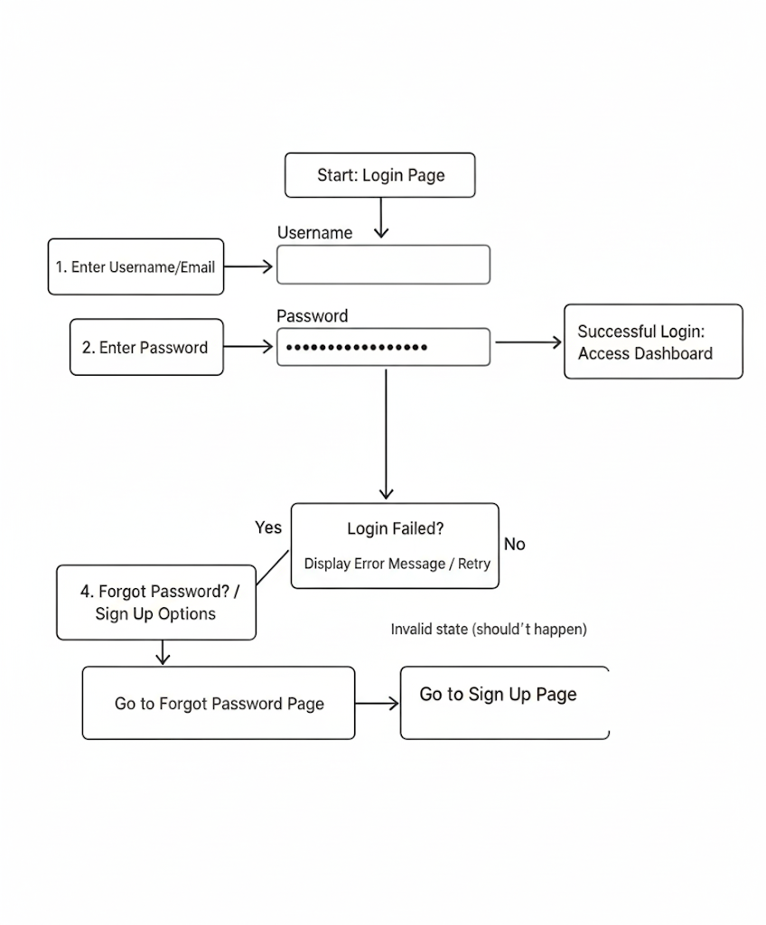
Figure 2.1: Login Page Mockup Explanation: The login page is designed for simplicity and ease of use. It features standard input fields for a username and password, a prominent login button, and links for password recovery and signing up. This minimalist approach reduces clutter and allows users to access the system quickly.

2.2.2 Sign Up Page
This page allows new users (Field Officers or Beneficiaries) to request an account, which will be approved by an administrator.
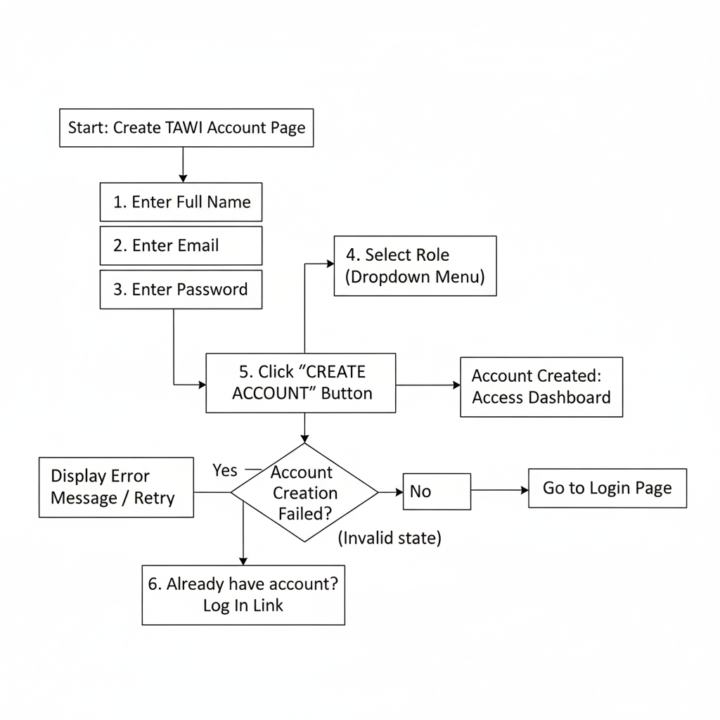
Figure 2.2: Sign Up Page Mockup Explanation: The sign-up form collects essential information: full name, email for communication, a secure password, and the user's role (e.g., Field Officer, Beneficiary). This structured data capture ensures that administrators have the necessary details to approve and provision new accounts correctly.

2.2.3 Customer (Beneficiary) Registration Page
This form is used by an Administrator to formally register a new beneficiary into the system, linking them to a specific project or location.
Figure 2.3: Customer Registration Page Mockup Explanation: This is an internal form for administrators. It captures key details needed for project tracking, such as the beneficiary's

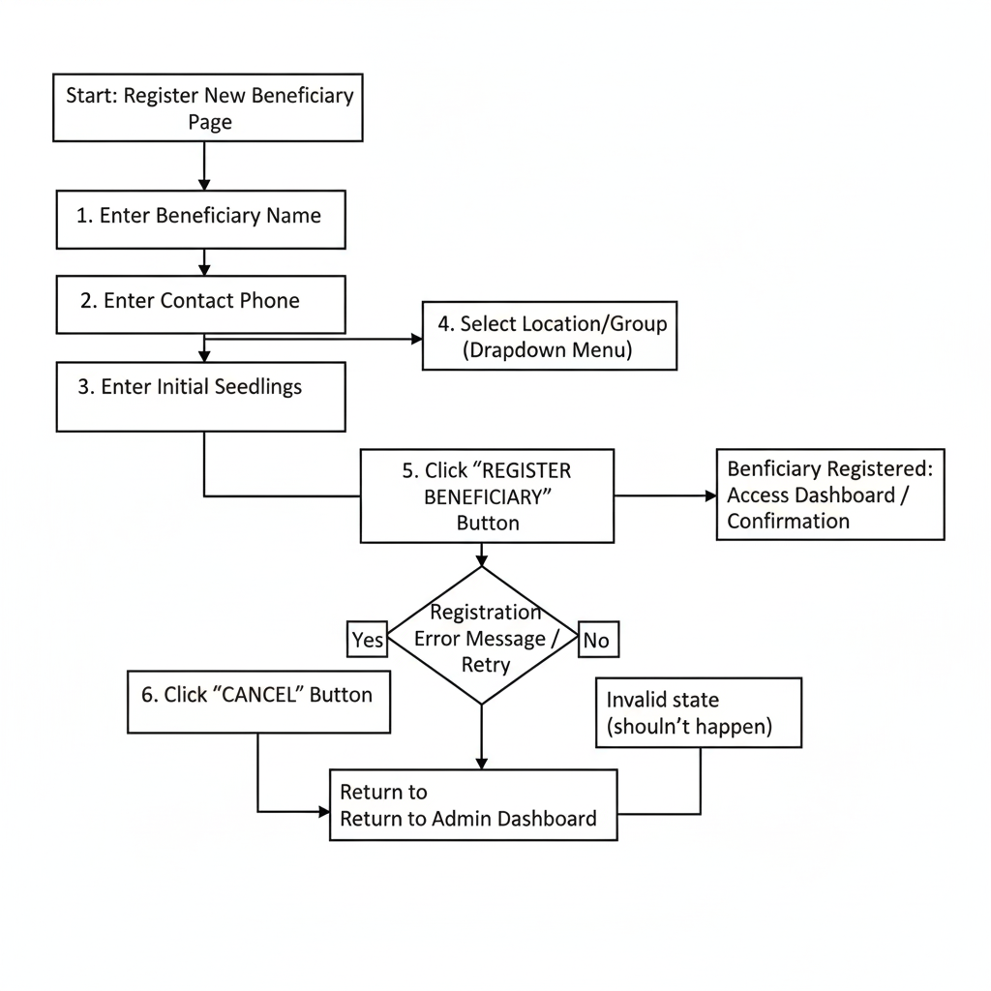name, contact information, their assigned group or location, and the initial number of seedlings distributed. This ensures data integrity from the start.

2.2.4 Admin Dashboard Form
The dashboard provides administrators with a high-level overview of system activity and quick access to management functions.
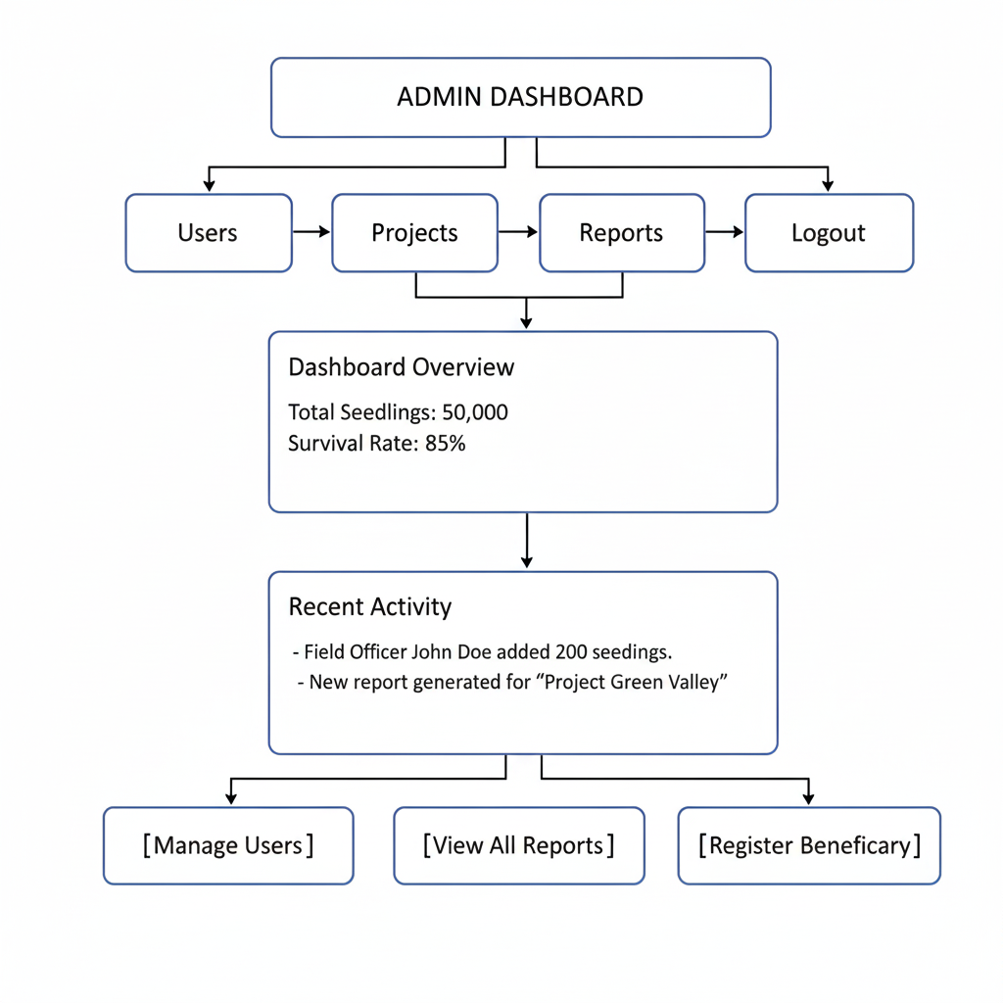Figure 2.4: Admin Dashboard Form Mockup Explanation: The admin dashboard is designed as a command center. Key performance indicators (KPIs) like total seedlings and survival rate are displayed prominently. It also includes a feed of recent activities and provides direct links to core administrative tasks like user management, viewing reports, and registering new beneficiaries, streamlining the admin workflow.

2.2.5 Seedling Catalog Access Page
This page provides access for users who wish to browse available seedling types and project information without full data-entry privileges.
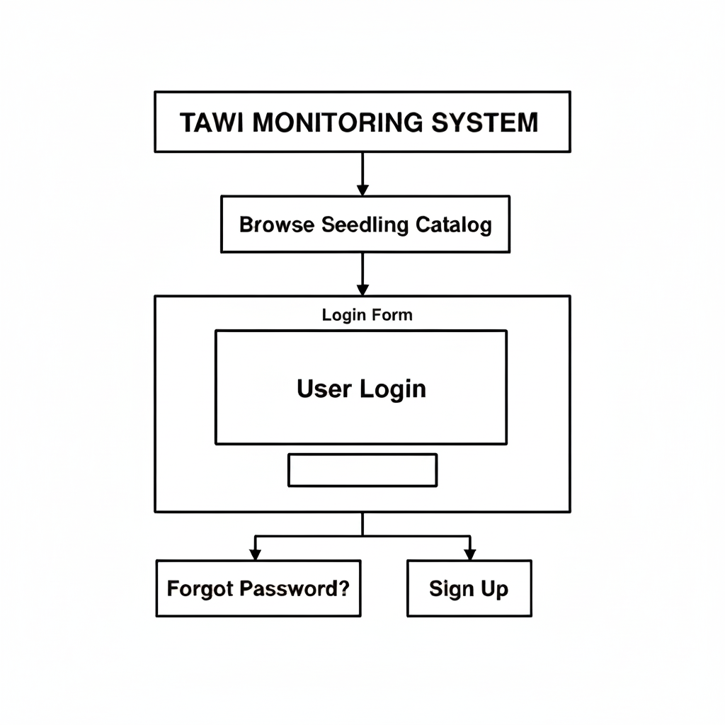
7Figure 2.5: Seedling Catalog Access Page Mockup Explanation: This login is for guest or limited-access accounts, allowing users to explore available seedling types and project details. It encourages engagement while keeping data entry secured.

2.2.6 Field Officer Login Page
This is the main login portal for registered Field Officers, granting access to record seedling distribution, update monitoring data, and manage their assigned areas.
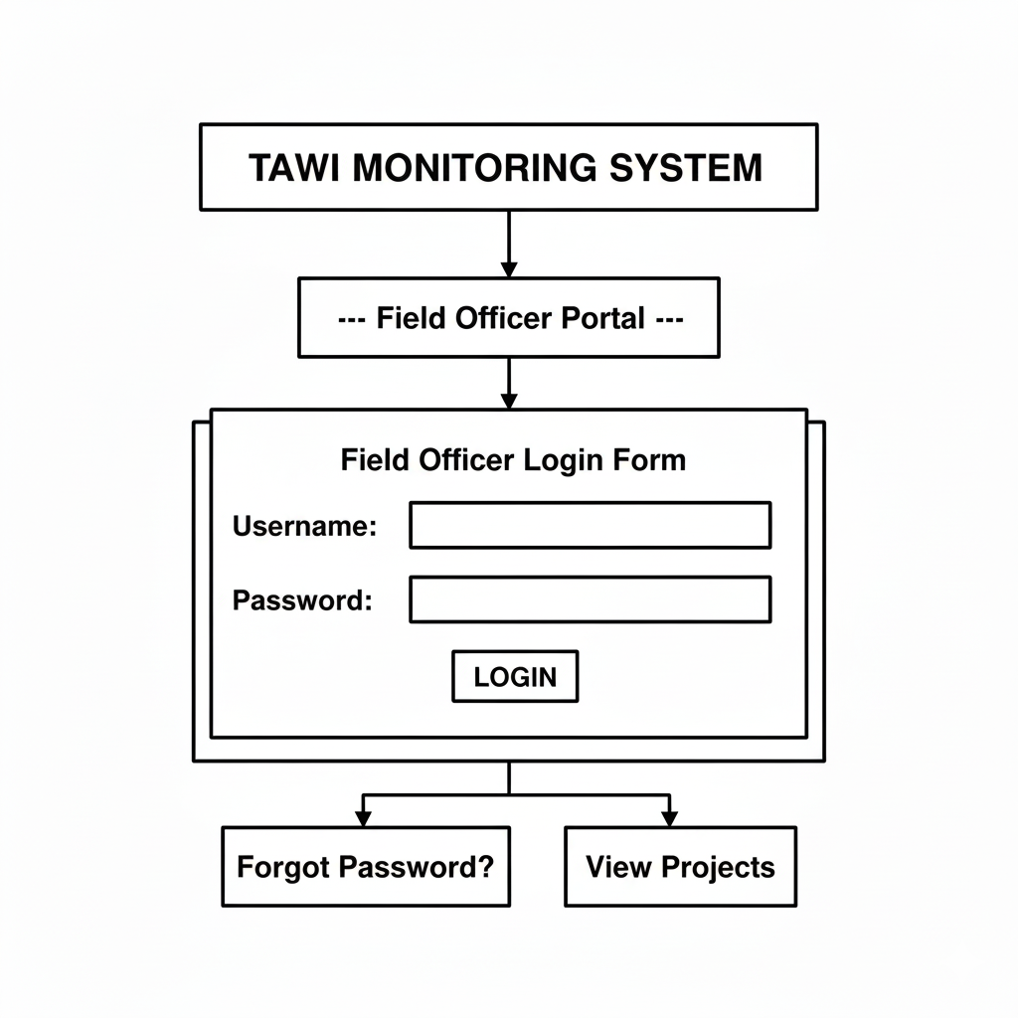
Figure 2.6: Field Officer Login Page Mockup Explanation: This secure login authenticates field staff, giving them access to the core data-entry functionalities of the system.

2.3 Admin Module Login Page
This form provides secure, role-based access for administrators to manage project funds, view financial reports, and oversee system-wide settings.
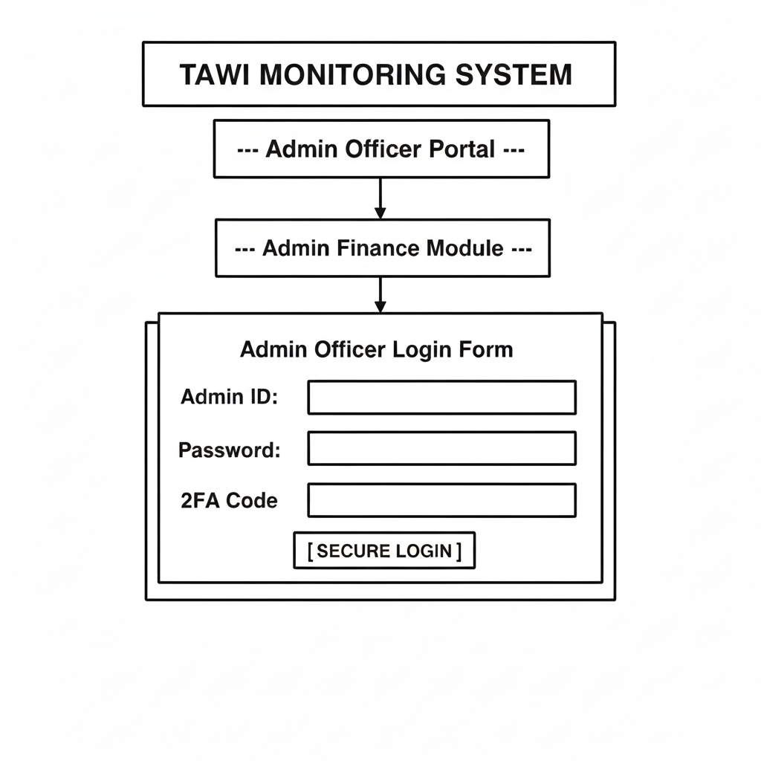
Figure 2.7: Admin Module Login Page Mockup Explanation: Designed with enhanced security for financial management, this login requires two-factor authentication (2FA) to ensure only authorized personnel can access sensitive project data.

This section describes the system's process flow.

2.3 Logic Models

2.3.1 Data Submission Flowchart
Illustrates how a field officer submits new seedling data.
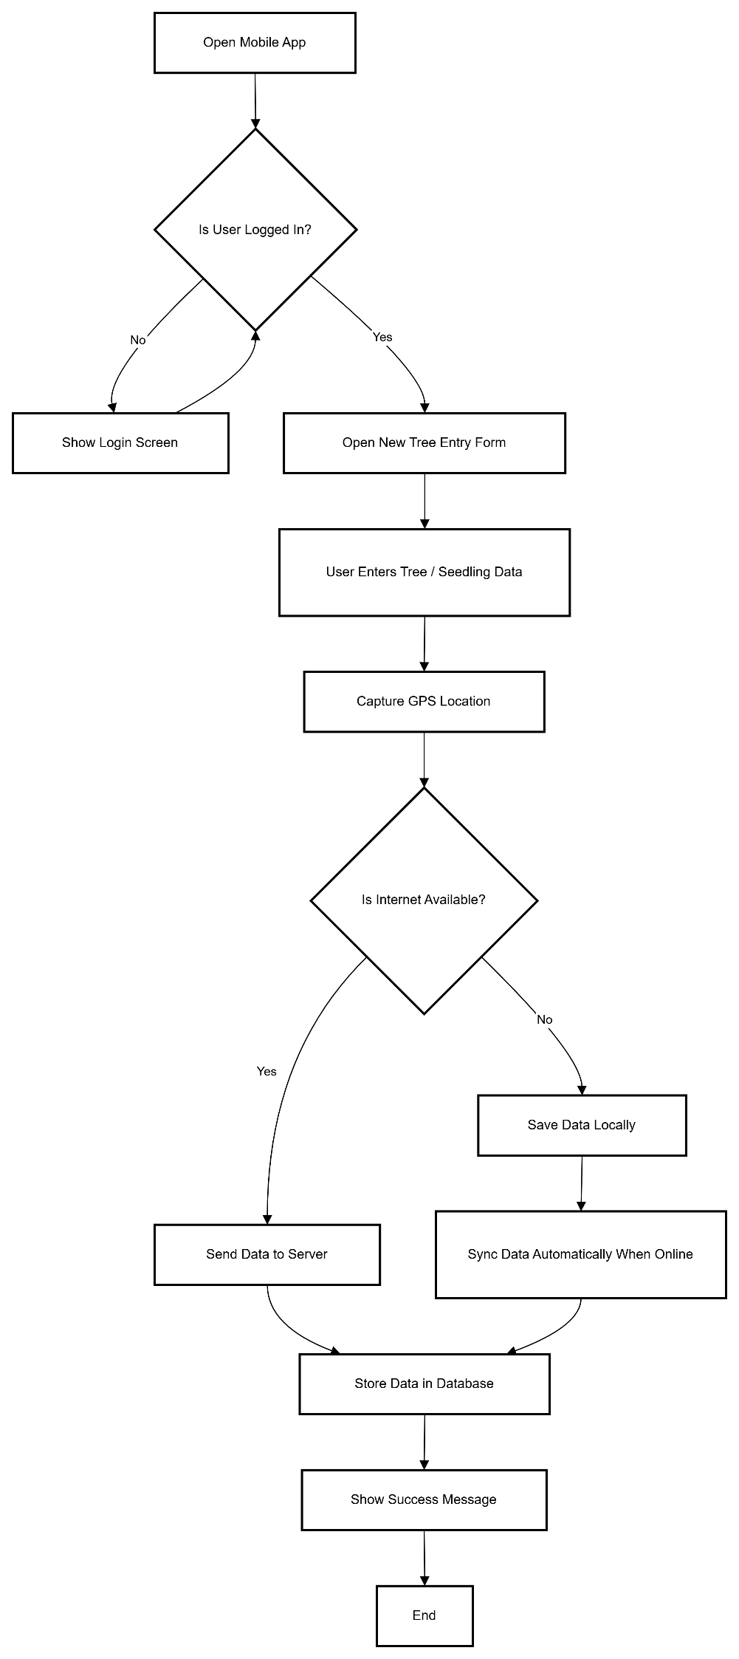

Figure 2.5: Data Submission Flowchart
Explanation :
- Start: User opens the mobile app.
- Login Check: The system verifies if the user is logged in. If not, the login screen is displayed.
- New Entry: Once logged in, the user opens the “New Tree Entry” form and fills in tree/seedling data.
- GPS Capture: The app captures the GPS location of the tree.
- Internet Check: The system checks for an active internet connection.
- Data Submission (Online): If online, data is sent to the server and stored in the database, and a success message is shown.
- Data Submission (Offline): If offline, the data is saved locally and synchronized automatically when the device reconnects.
- End: Data is safely stored in the database and the user receives feedback.

2.3.2: Login Flowchart
This flowchart describes how a user logs into the system.
- The process starts when the user opens the application.
- The system first checks whether the user is already logged in.
- If the user is already logged in, they are directly redirected to the dashboard.
- If the user is not logged in, the system displays the login screen.
- The user enters their username and password.
- The system validates the credentials using the database.
- If the credentials are correct, the user is redirected to the dashboard.
- If the credentials are incorrect, an error message is displayed and the user is returned to the login screen.
This flow ensures secure access to the system.
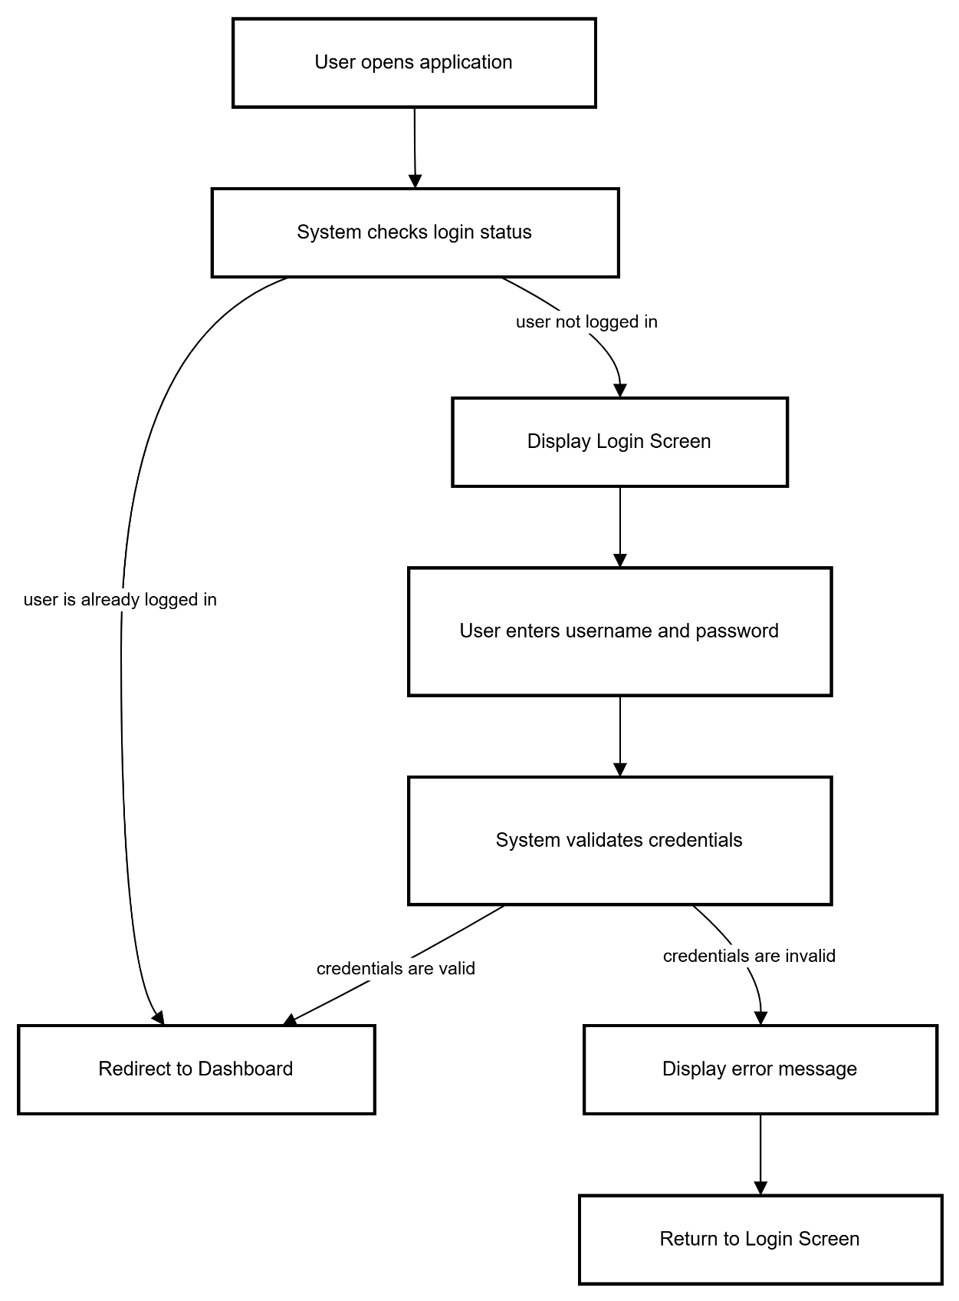

2.3.3: Sensor Data Processing Flowchart
This flowchart shows how tree sensor data is handled.
- The process starts when the IoT sensor collects data such as temperature, humidity, and soil moisture.
- The sensor sends this data to the server.
- The system stores the data in the database.
- The system checks whether the data values exceed the predefined threshold limits.
- If the data is within the normal range, the dashboard is updated.
- If the data is outside the normal range, the system generates an alert and notifies the user.
This helps in early detection of unhealthy tree conditions.
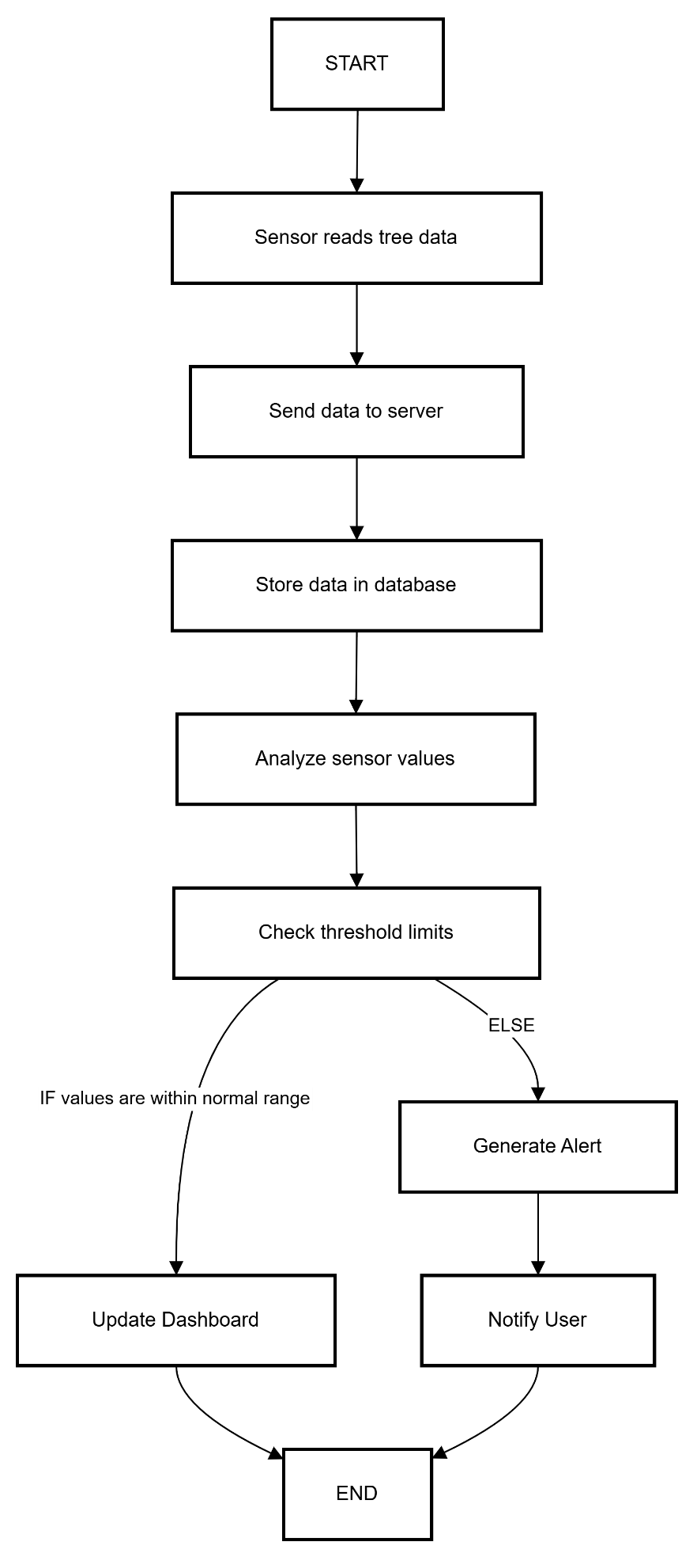

2.3.4: Alert Management Flowchart
This flowchart explains how alerts are created and managed.
- The process starts when new sensor data is received.
- The system compares the data with preset threshold values.
- If no threshold is exceeded, the system continues monitoring.
- If a threshold is exceeded, an alert record is created.
- The alert is stored in the database.
- A notification is sent to the user.
This ensures that users are informed immediately about critical conditions.
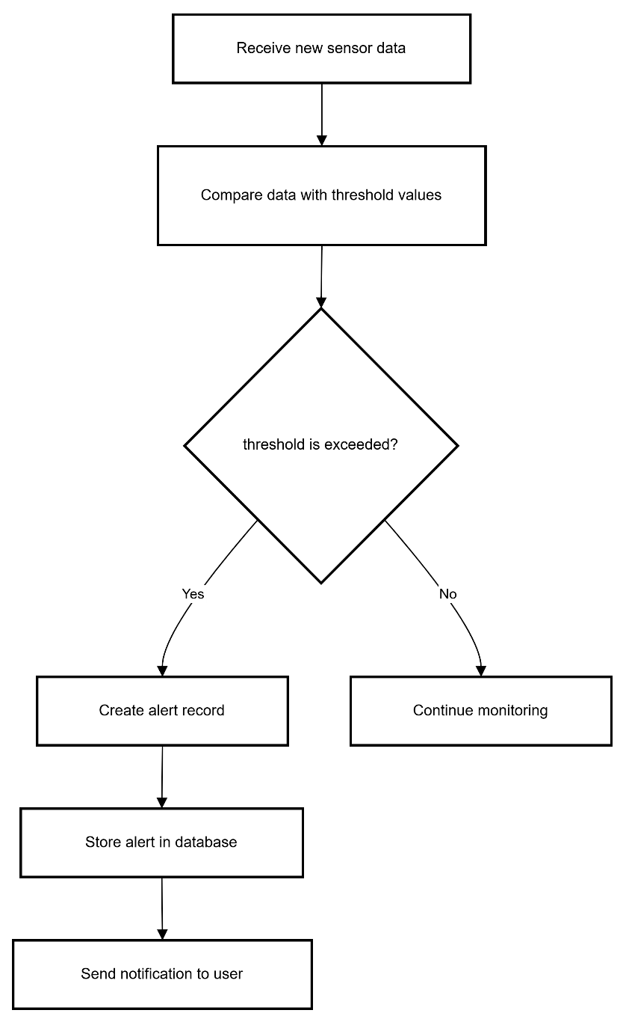

2.3.5: Admin Management Flowchart
This flowchart shows how the admin manages the system.
- The process begins when the admin logs into the system.
- The admin dashboard is displayed.
- The admin selects an option such as:
  - Manage Users
  - Manage Trees
  - View Reports
- If the admin selects Manage Users, they can add, edit, or delete user accounts.
- If the admin selects Manage Trees, they can add, update, or remove tree records.
- If the admin selects View Reports, the system generates and displays reports.
This allows full system control and maintenance.

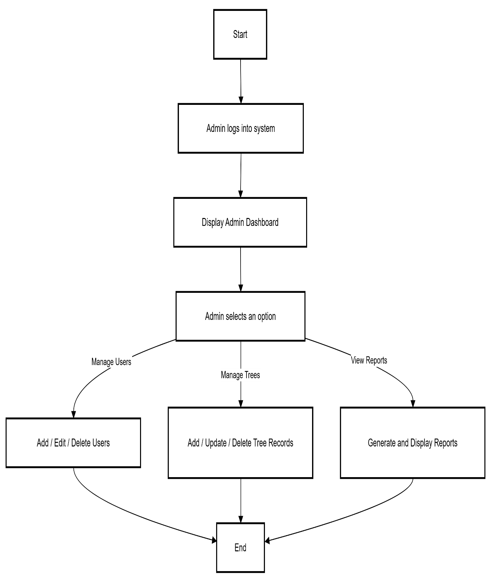

2.3.6: The sensor collects data from the tree.
- The data is sent to the server and stored in the database.
- The system analyzes the data.
System Monitoring Flowchart
This flowchart describes the overall monitoring logic.
- The system checks whether any value exceeds the threshold.
- If yes, an alert is triggered and the user is notified.
- If no, the dashboard is updated with the new data.
This flow represents the core working of the Digital Tree Monitoring System.

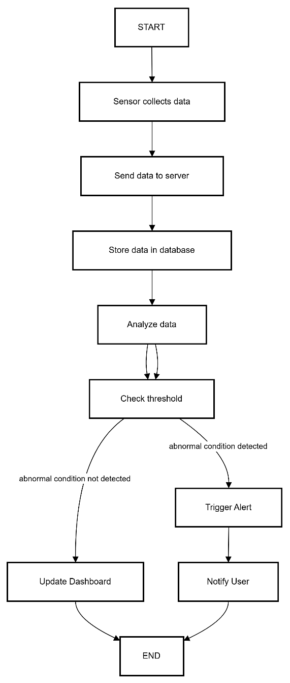

CHAPTER THREE: SYSTEM IMPLEMENTATION

3.1 Introduction
This chapter outlines the development journey of the Tawi Digital system. It details the transition from conceptual design to a functional web application, covering the construction of the user interface, the integration of server-side logic using PHP and MySQL, and the final testing phases. The goal of this chapter is to provide a technical roadmap of how the system’s features—such as seedling tracking and GPS mapping—were physically realized.

3.2 User Interface Development
The user interface for Tawi Digital was developed using a mobile-first approach, ensuring that field officers can access the system via smartphones while in the field. The design utilizes Bootstrap 5 for responsiveness and a custom CSS theme to reflect a modern, professional environmental platform.

3.2.1 Homepage Development
The homepage is designed as a landing page to introduce the Tawi Digital mission. It features a hero section with a call to action, an "About Us" summary, and quick links to the login and registration portals.
- Purpose: To provide a public-facing overview of the tree-tracking system and allow users to navigate to their respective dashboards.
- Design Elements: It uses a clean, high-contrast layout with nature-inspired imagery to align with the reforestation theme.

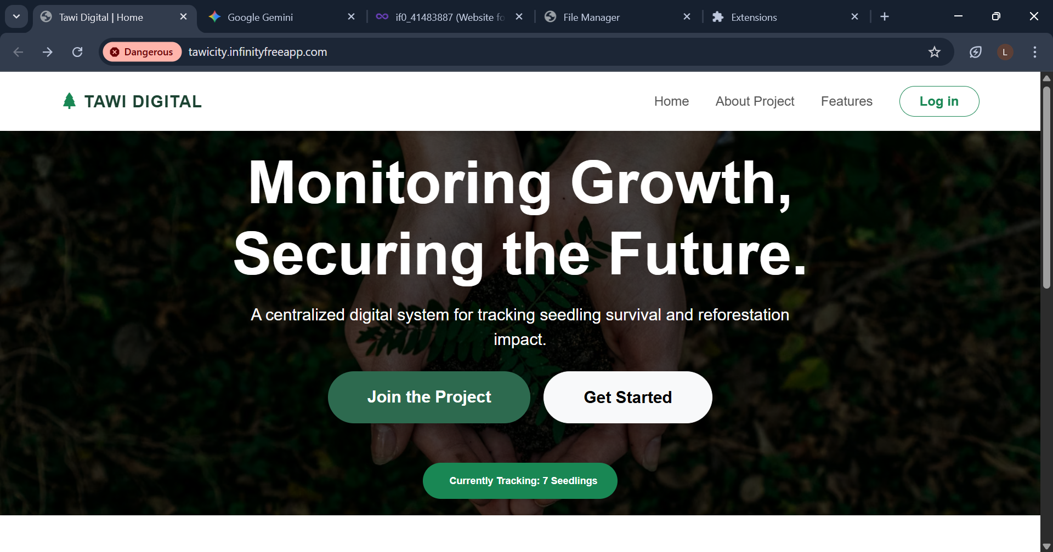
  - Caption: Figure 3.1: Tawi Digital Landing Page.
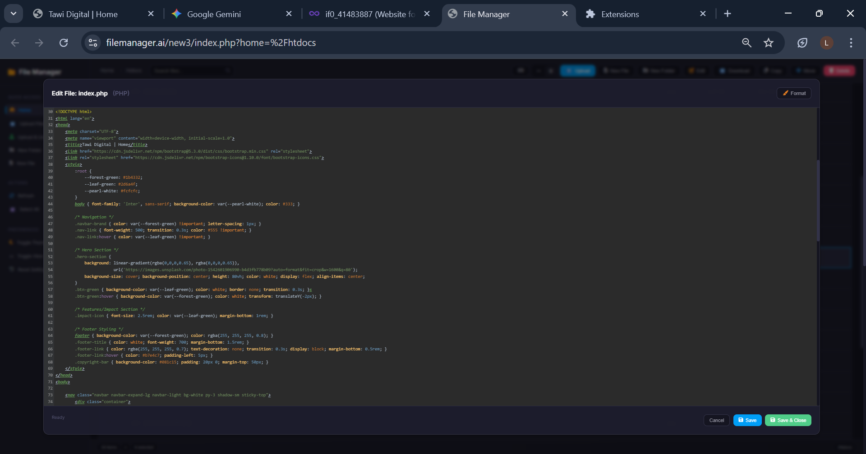
  - Caption: Figure 3.2: HTML CODE
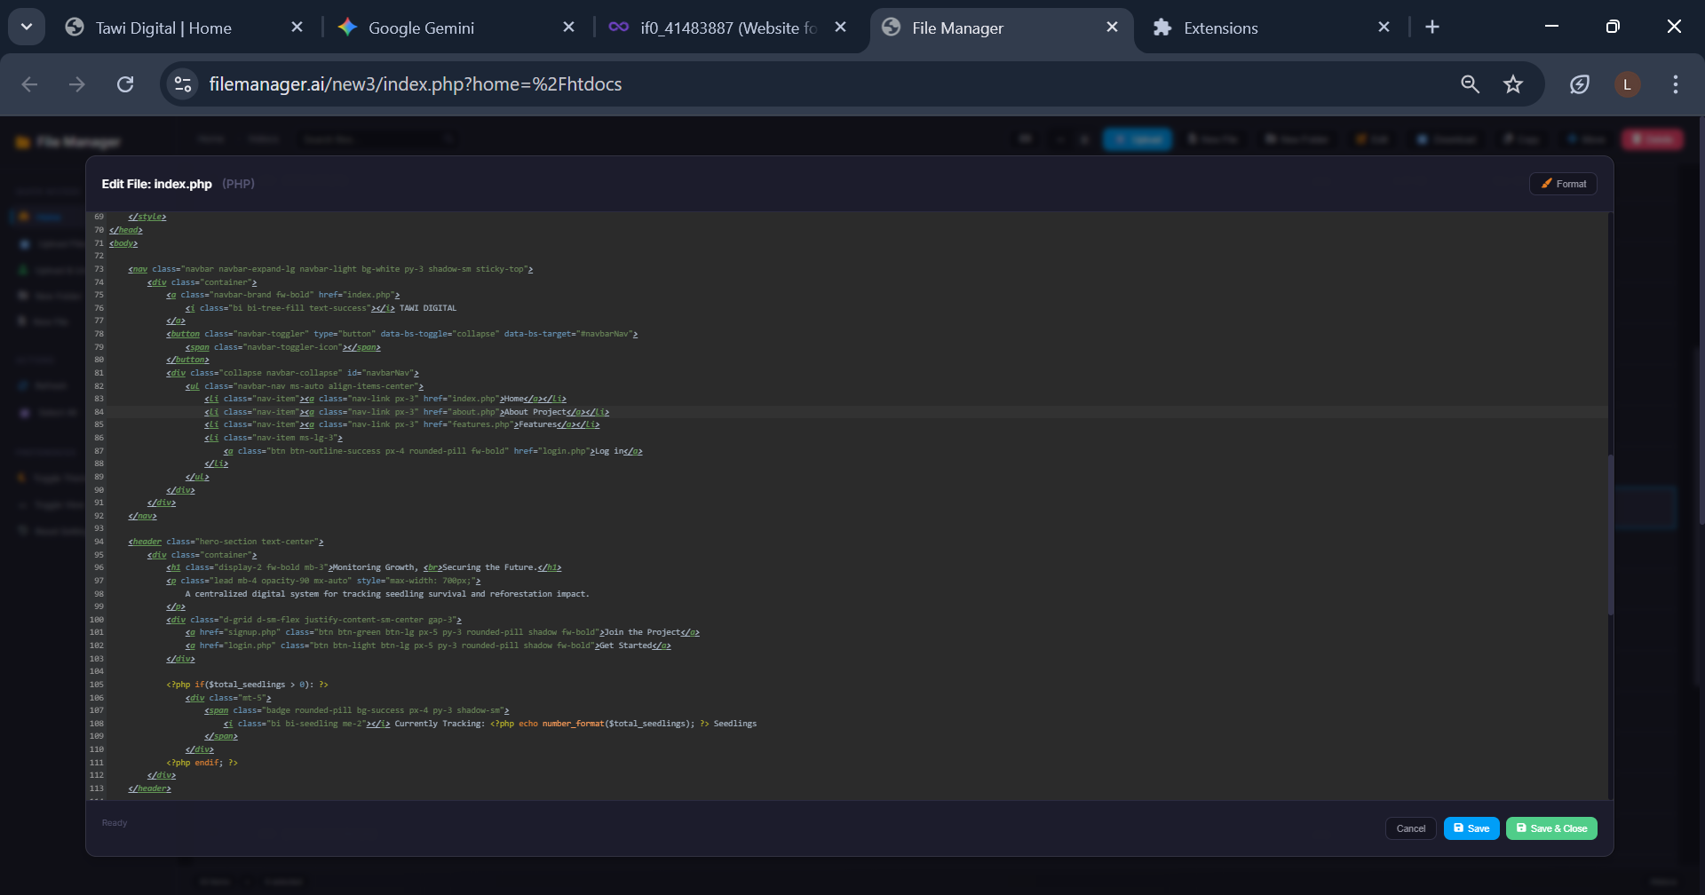
  - Caption: Figure 3.2: CSS CODE

3.2.2 Login and Authentication Interface
The login page was designed to be minimalist and secure, ensuring that only authorized field officers and admins can modify reforestation data.
- Purpose: To authenticate users based on their credentials stored in the MySQL database.
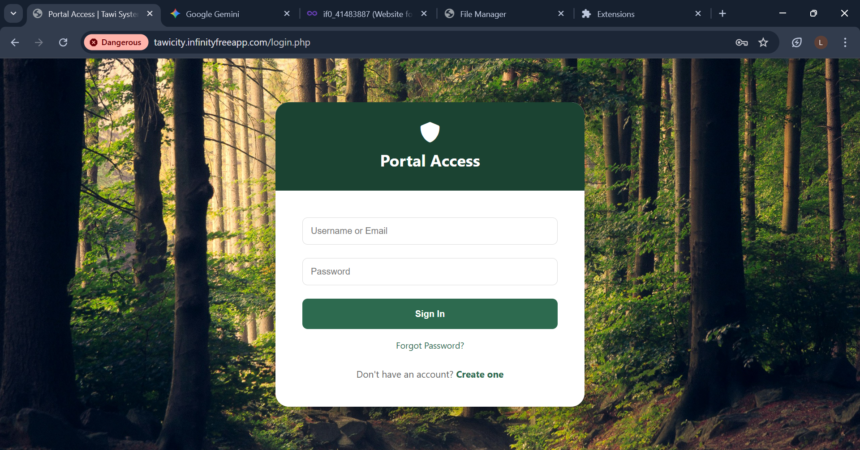
  - Caption: Figure 3.3: User Login Interface.
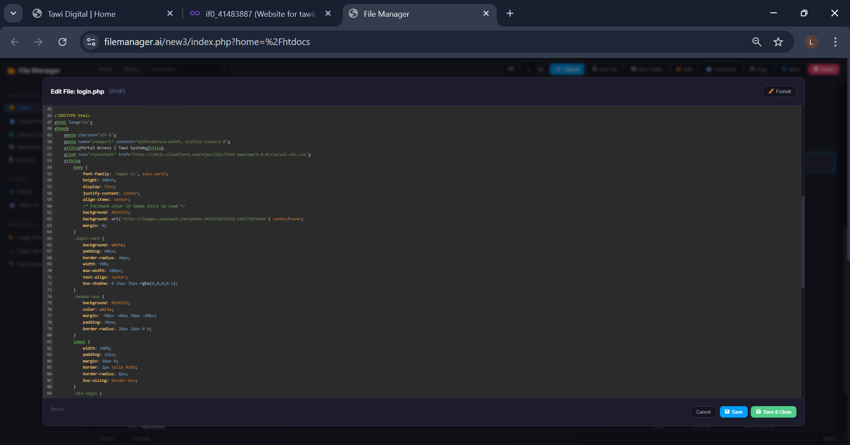
  - Caption: Figure 3.4: HTML CODE

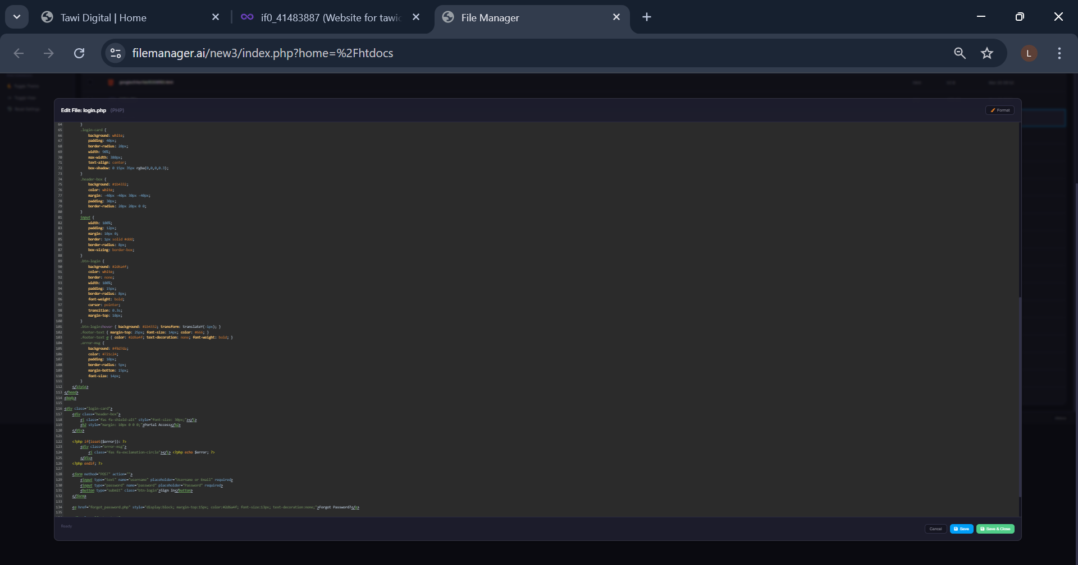
  - Caption: Figure 3.4: CSS CODE
3.2.3 Sign-Up (Account Creation)
Following the login, the sign-up interface allows new partners to register. This page captures user details that are necessary to initialize their digital forest profile.
- Purpose: To register new users and create a unique user_id in the database.
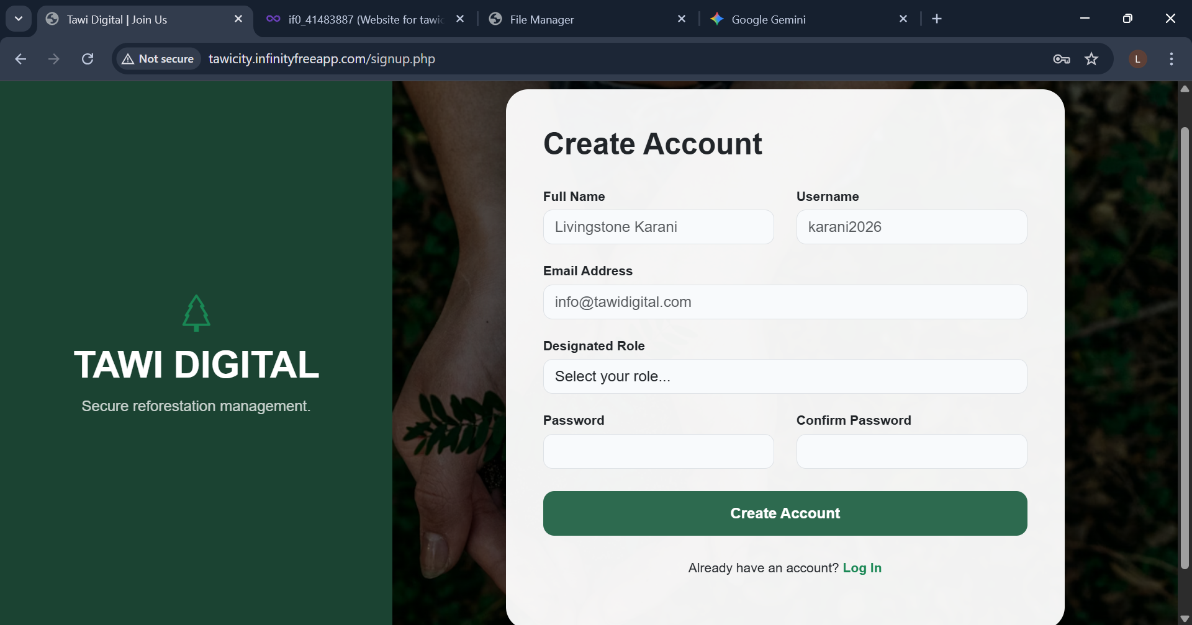

  - Caption: Figure 3.5: Sign-up form capturing user name, email, and password.
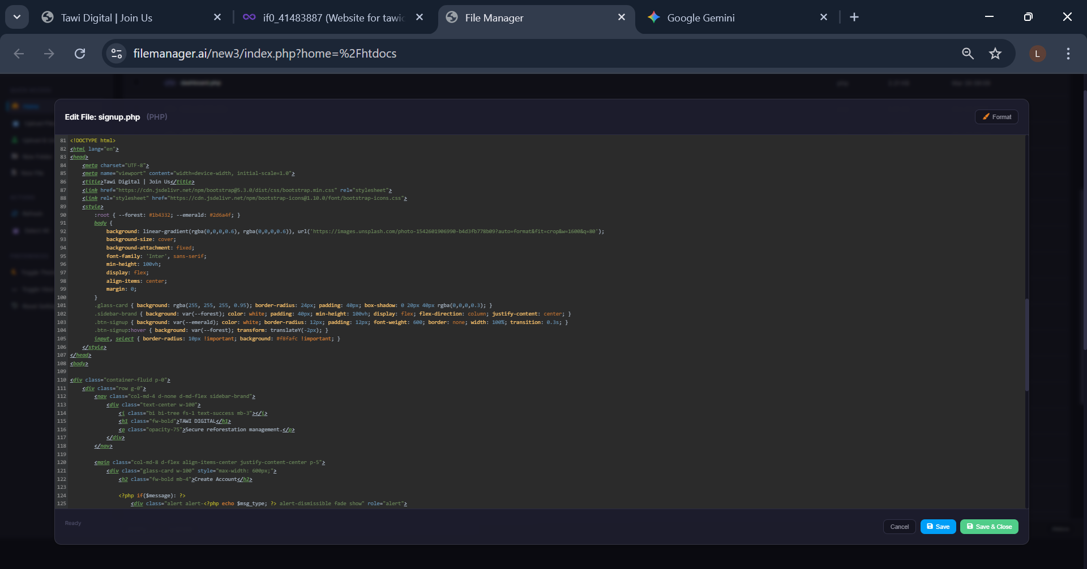
Caption: Figure 3.5:HTML CODE
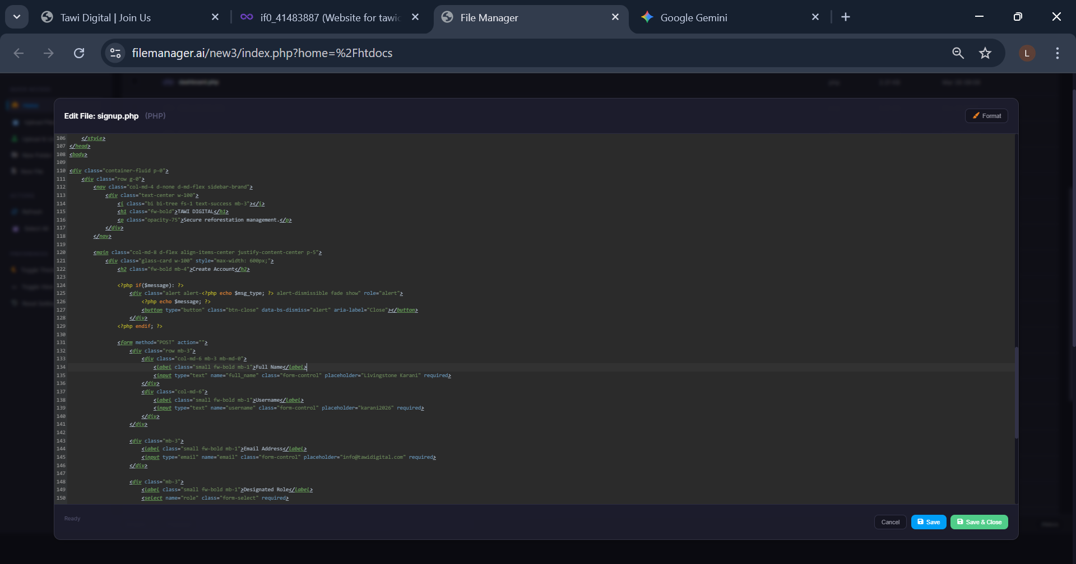
Caption: Figure 3.5 CODE CSS

3.2.4 Beneficiary Dashboard
Once registered, users are directed to the Beneficiary Dashboard. This interface utilizes a "Glassmorphism" style for statistical cards to show KES balances, tree counts, and CO2 offsets.
- Purpose: To provide beneficiaries with a "live" view of their environmental impact and financial standing.

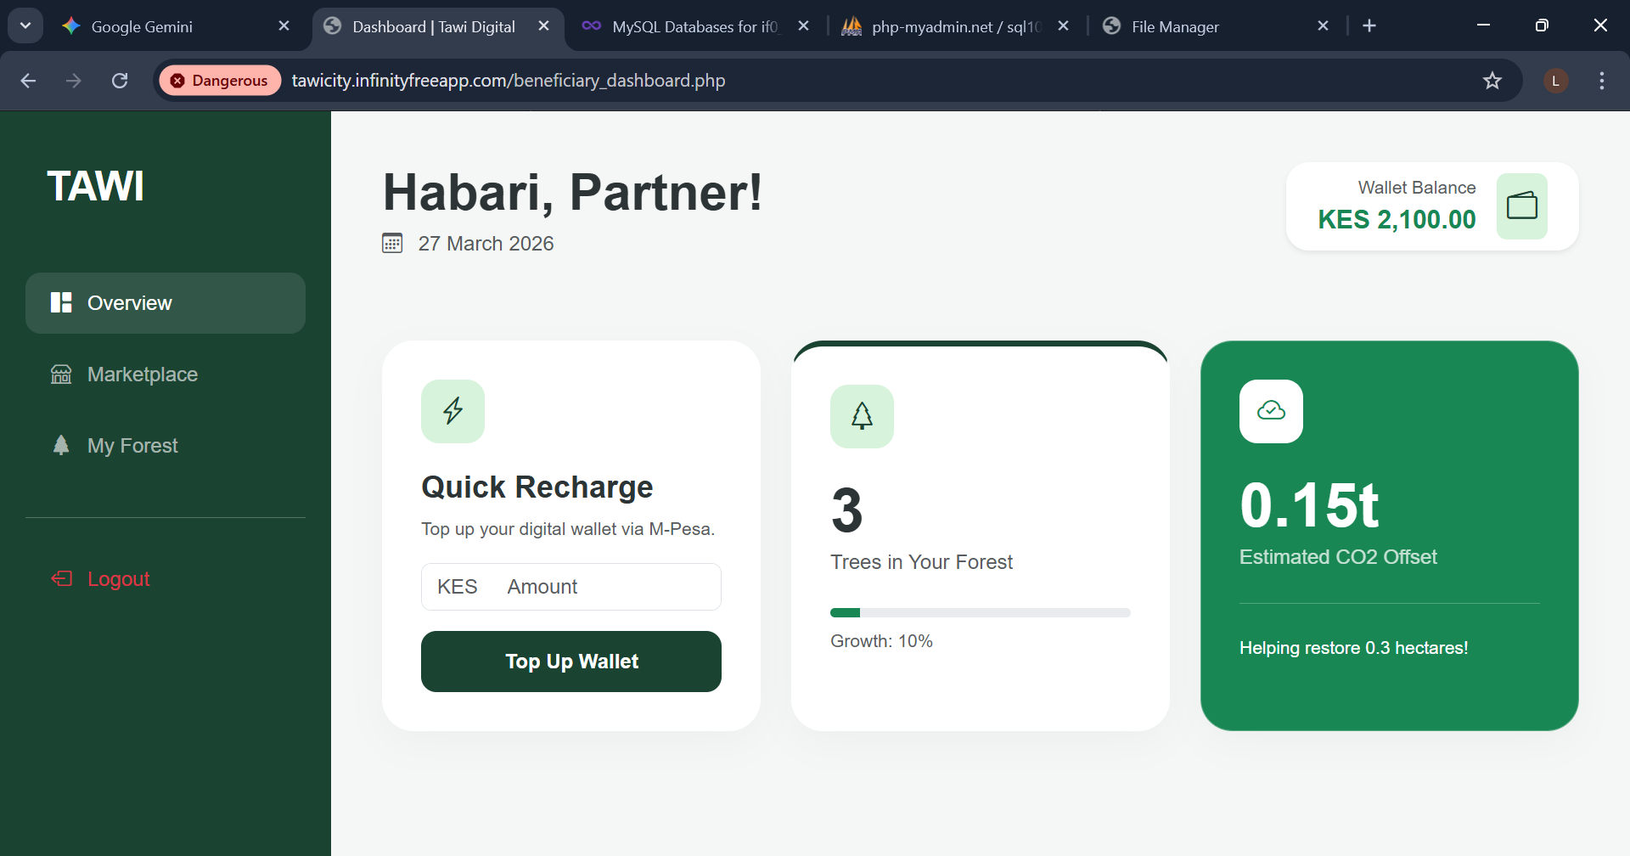
  - Caption: Figure 3.4: BENEFICIARY DASHBOARD
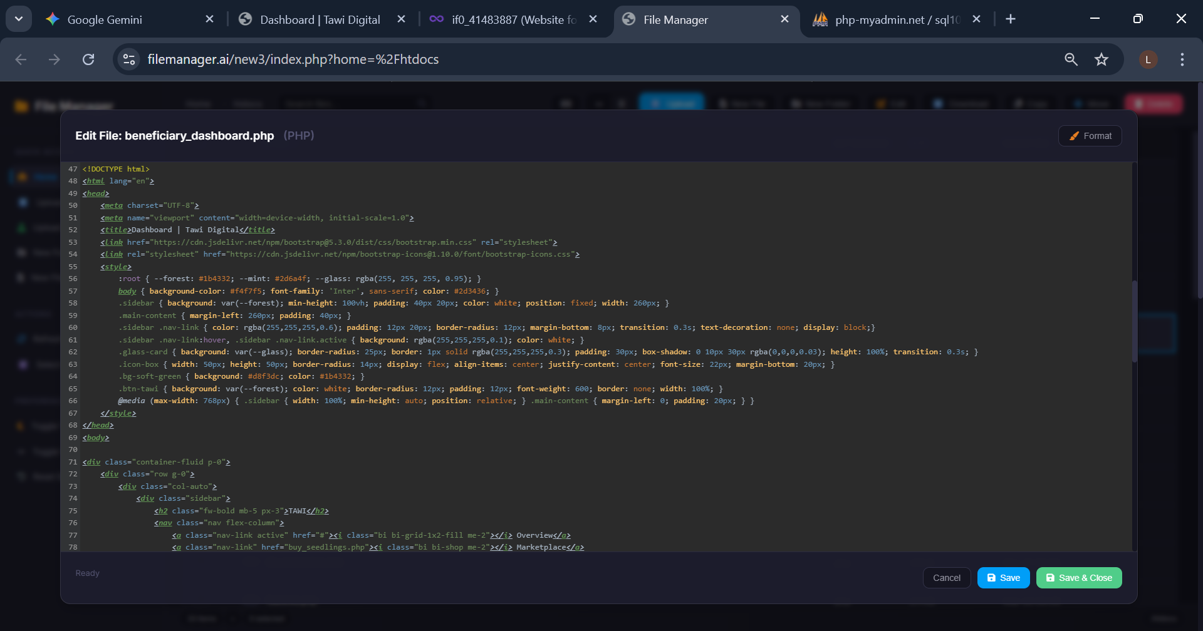
Caption: Figure 3.4: HTML CODE

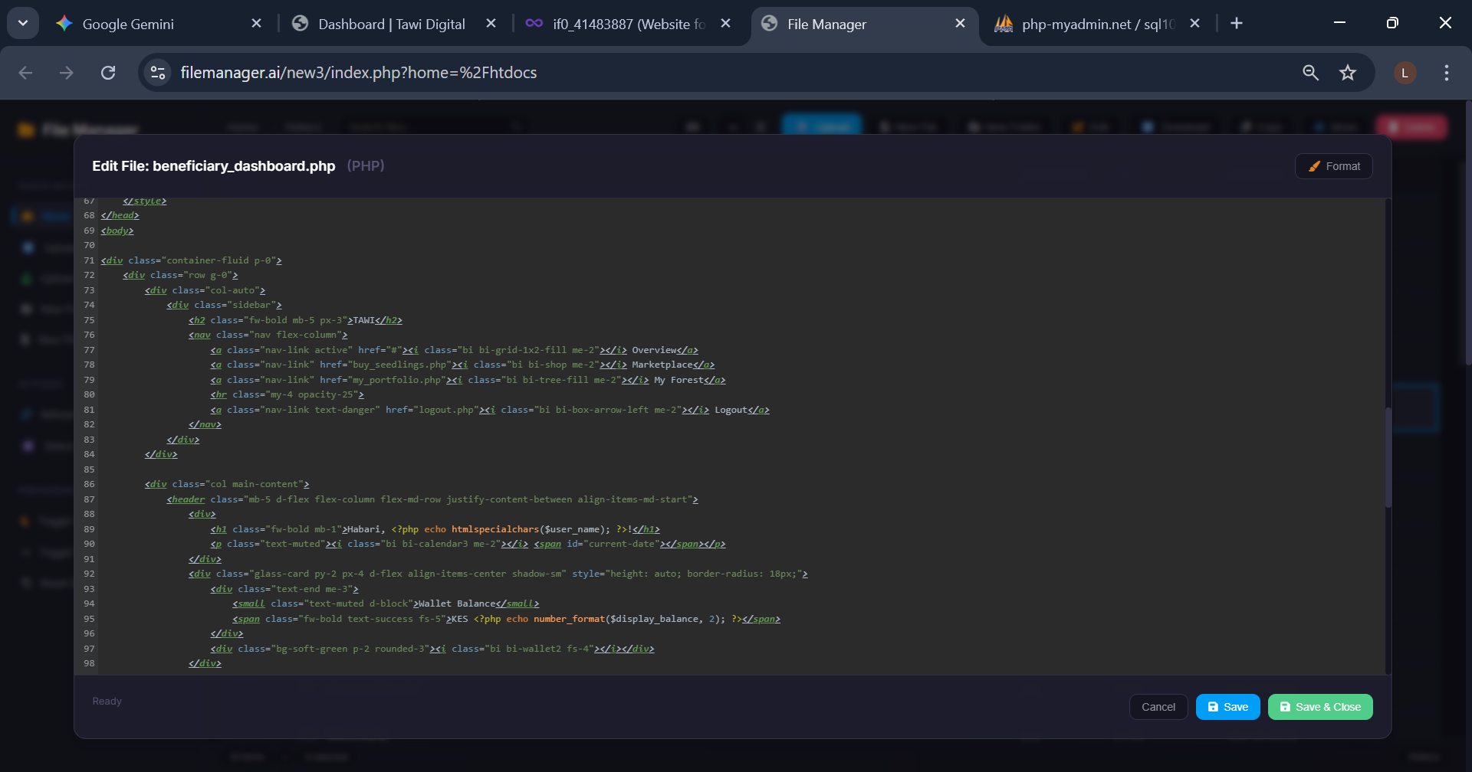
Caption: Figure 3.4: CSS CODE

3.2.5 Administrative Dashboard & Reports
The admin side is designed for regional oversight. It features a "Quick Data Summary" table and a dedicated reports page to track reforestation zones.
- Purpose: To allow system administrators to monitor user activity and regional planting progress.
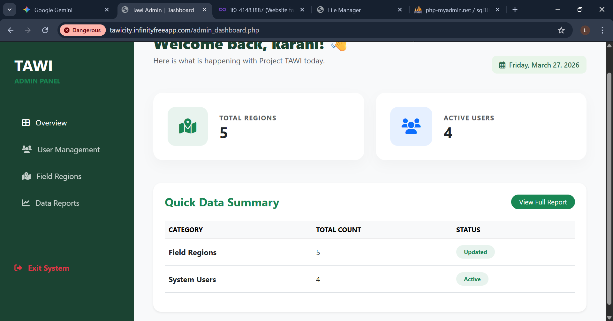
Caption: Figure 3.5: Administrative dashboard
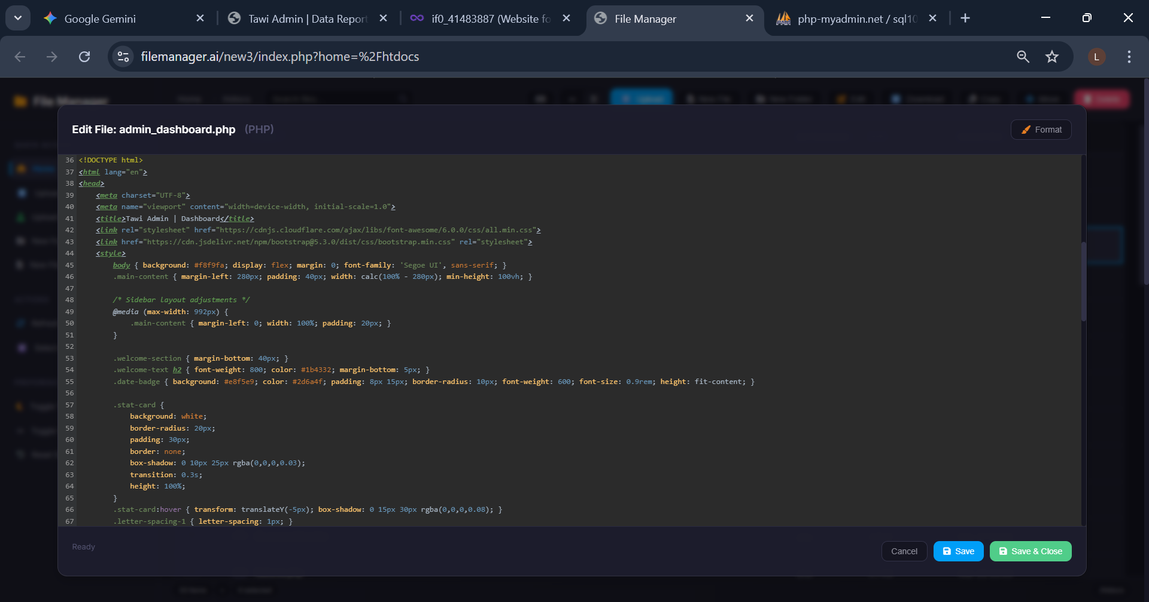
Caption: Figure 3.5:1 HTML code
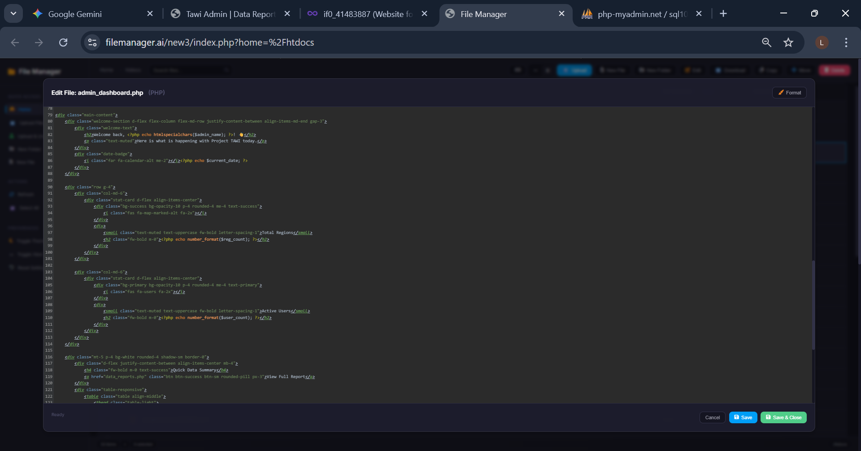
Caption: Figure 3.5:2 CSS code
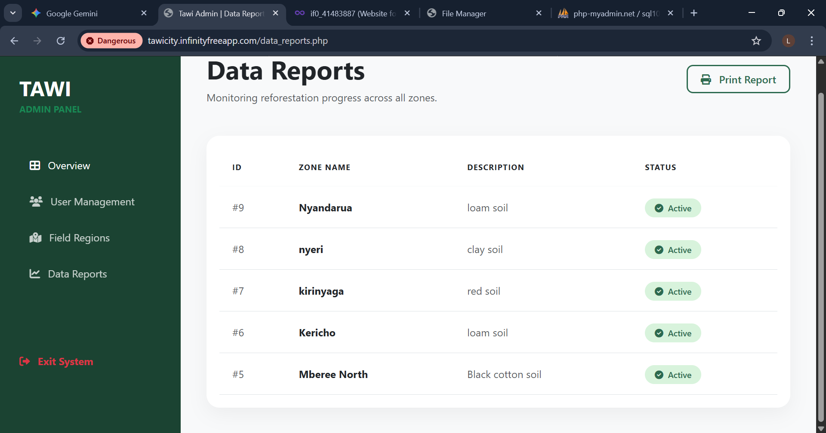
  - Caption: Figure 3.5:3 Administrative reporting interface for regional data.
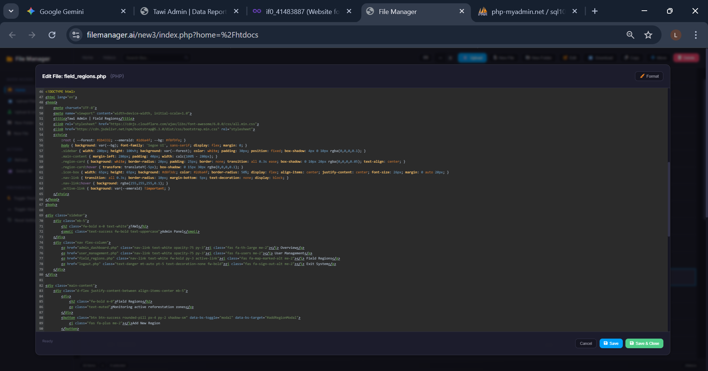
Caption: Figure 3.5:4 HTML code
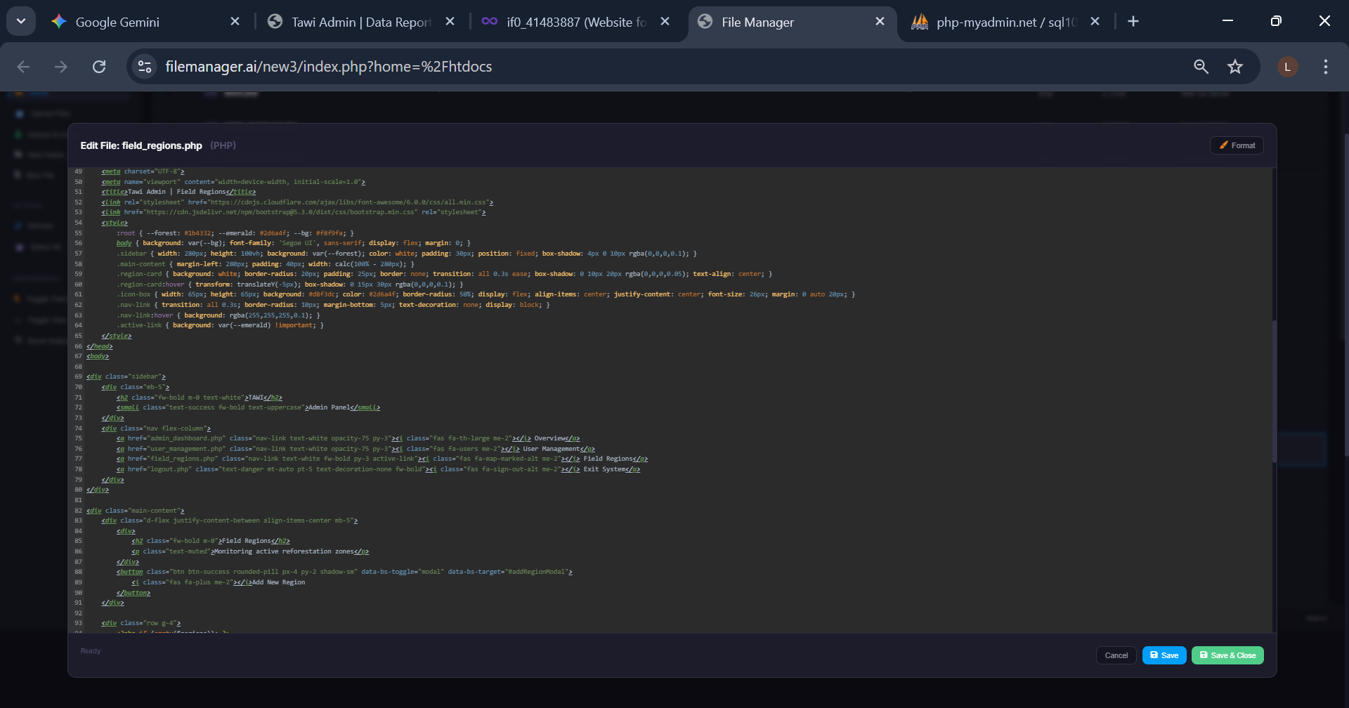
Caption: Figure 3.5:5 CSS code

3.2.6 Officer / Regional Management Dashboard
The Officer Dashboard is designed for field coordination. Unlike the beneficiary view, this interface focuses on Regional Oversight.
- Purpose: To allow field officers to view "Field Regions" and "System Users" counts.
- UI Elements: It features a "Quick Data Summary" table that pulls live counts from the regions and users tables.
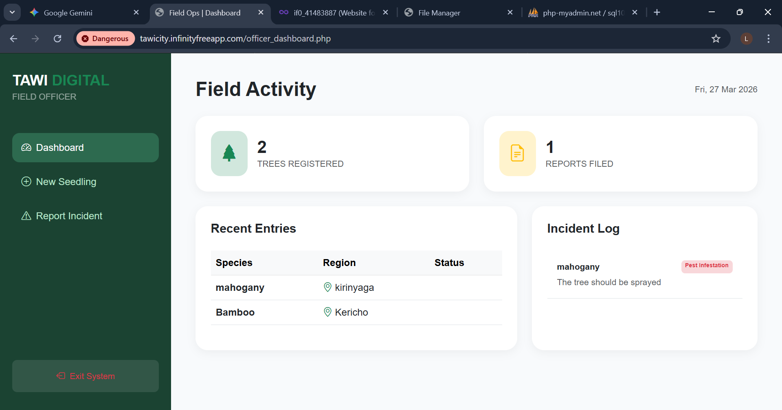
Caption: Figure 3.2:1 officer dashboard interface
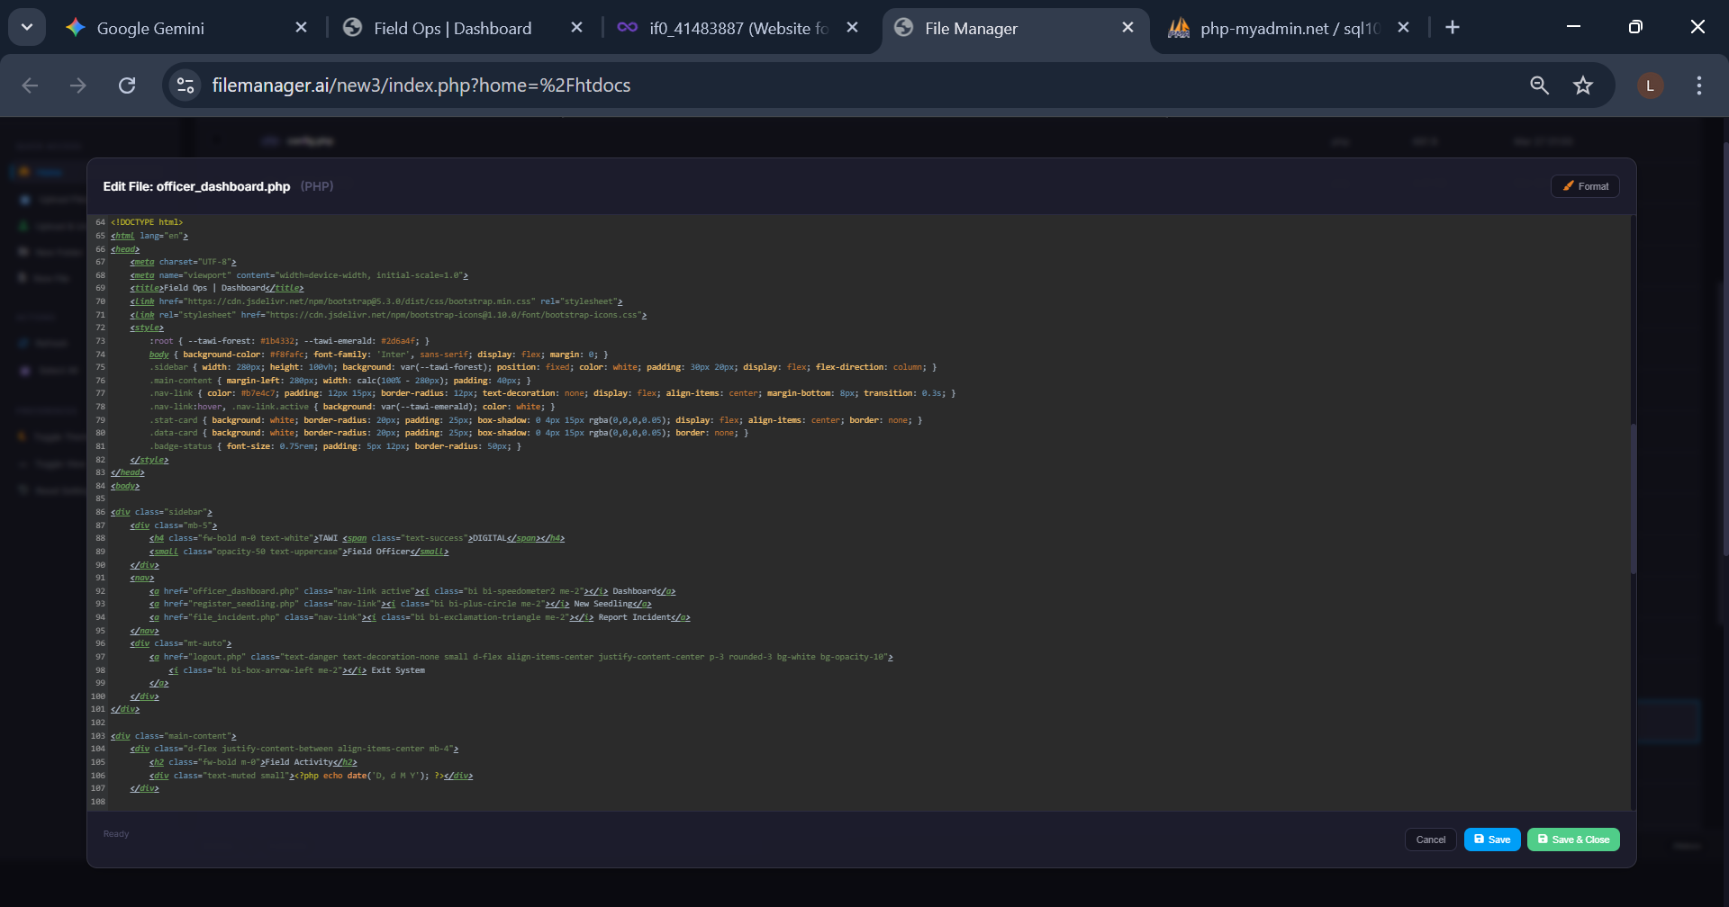
Caption: Figure 3.2:2 HTML code
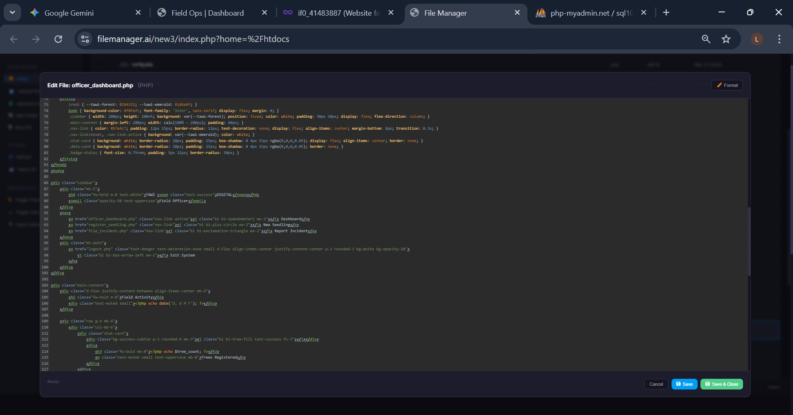
Caption: Figure 3.2:3 CSS code

3.3 Logic Development
The logic side handles the "heavy lifting"—processing data, managing sessions, and interacting with the database using PHP (PDO) for enhanced security against SQL injection.

3.3.1 Login Validation Code
This script processes the credentials entered in the login form. It checks the database for a matching username and verifies the hashed password.
- Logic Overview: The system uses session_start() to keep the user logged in and redirects them based on their success or failure.
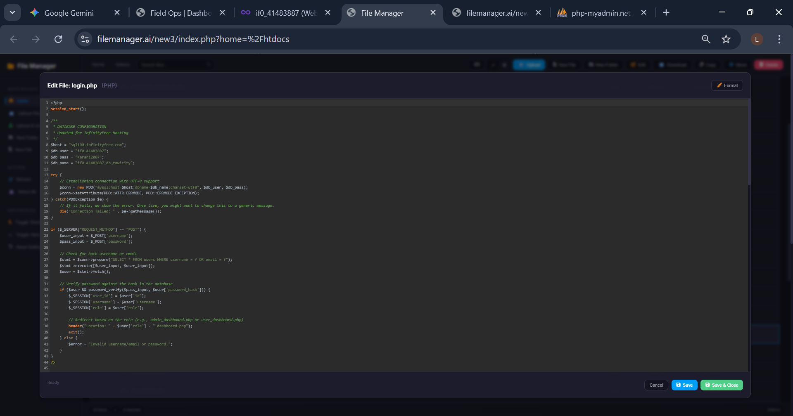
  - Caption: Figure 3.6: PHP logic for user validation and session management.

3.3.2 Seedling Registration and GPS Logic
This module handles the submission of new tree data, including species type and GPS coordinates for mapping.
- Logic Overview: It captures form data and executes an INSERT statement into the seedlings table.
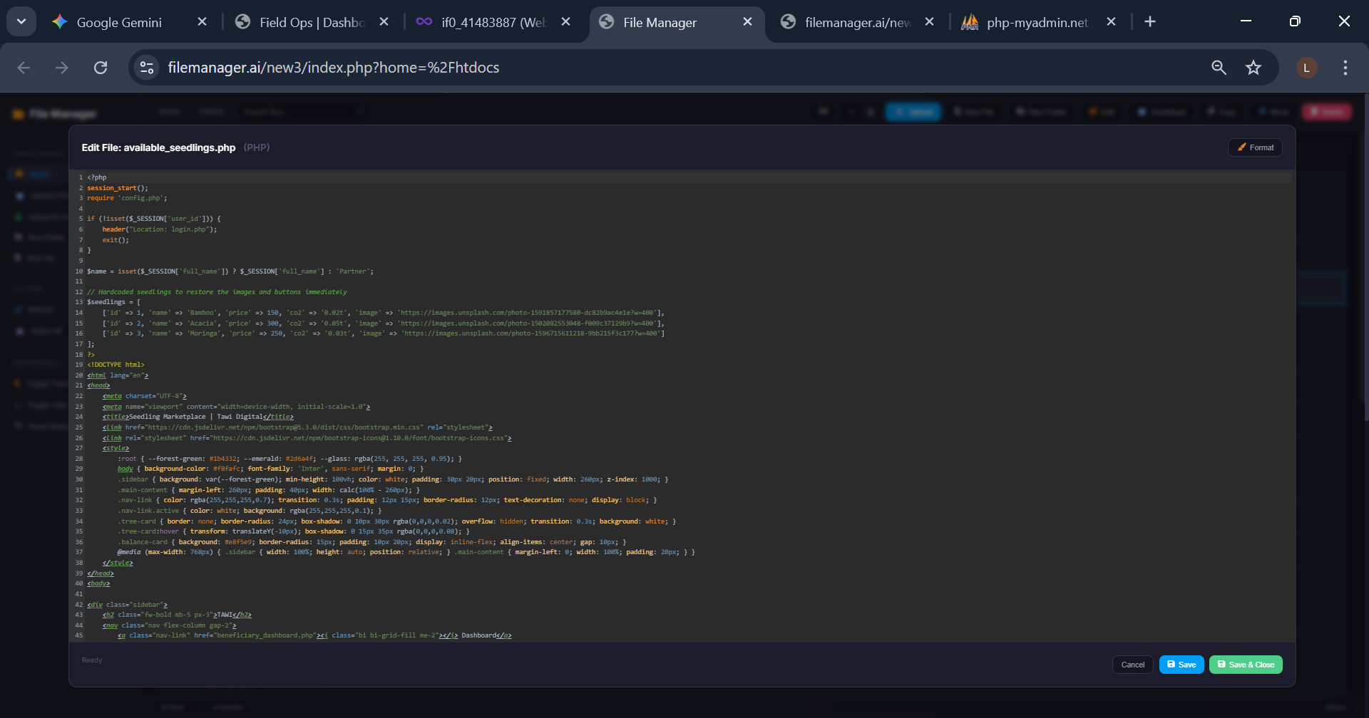
  - Caption: Figure 3.7: Logic for processing and storing tree monitoring data.

3.3.3 Wallet and Top-Up Logic
The financial module manages the reforestation funds. It ensures that when a user tops up their account, the balance is updated accurately in the database.
- Logic Overview: It uses an UPDATE query to increment the balance column in the users table while recording the transaction history.
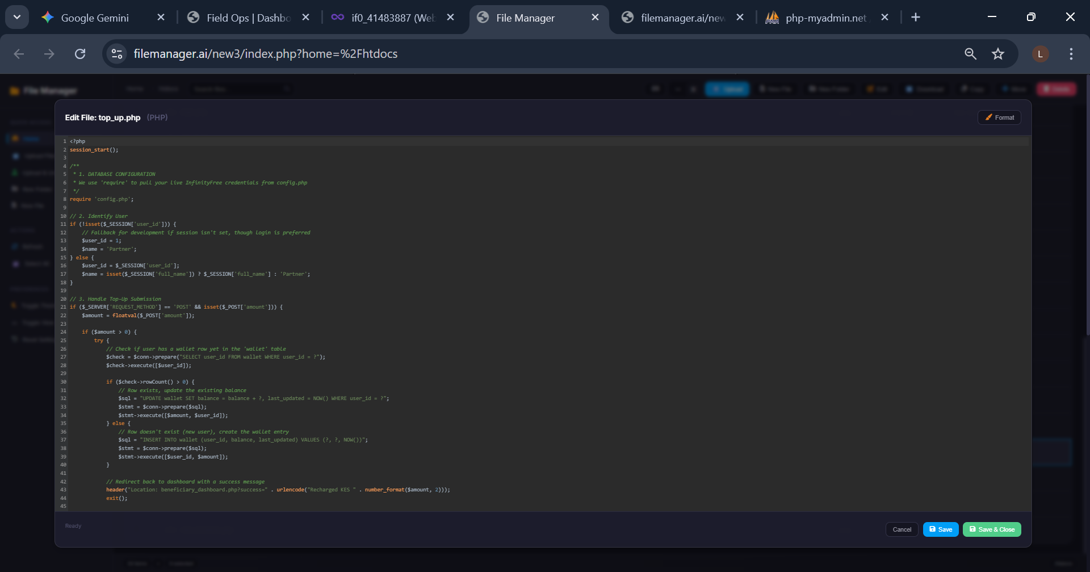
  - Caption: Figure 3.8: Logic for financial transaction processing.

3.4 Testing
Testing was a critical phase in the Tawi Digital development cycle to ensure that environmental data remained accurate and that financial transactions (seedling purchases) were secure. This section details the functional tests performed and the technical corrections made.

3.4.1 Database Connectivity and Environment Testing
Since the system was moved from a local XAMPP environment to live hosting, testing the database connection was the first priority.
- Action: I tested the config.php and db_connection.php files by attempting to load the homepage.
- Issue Found: The local "root" credentials failed when uploaded to the server, resulting in a "PDOException."
- Correction: I updated the connection logic to use the InfinityFree host (sql100.infinityfree.com) and corrected the database name to include the hosting prefix (if0_41483887_db_tawicity).

3.4.2 Authentication and Session Security Testing
I tested the "Gatekeeper" logic to ensure that user dashboards could not be accessed by unauthenticated users.
- Action: I attempted to access beneficiary_dashboard.php and admin_dashboard.php directly via the browser URL without logging in.
- Observation: Initially, the page would partially load before redirecting, which was a security risk.
- Correction: I added an exit(); command immediately after the header("Location: login.php"); line in the logic to ensure all script execution stops the moment a session is found to be missing.

3.4.3 Seedling Marketplace and Wallet Validation
Testing the "Buy Now" feature was essential to prevent users from buying trees with insufficient funds.
- Action: I attempted to purchase a Moringa seedling (KES 250) using an account with a wallet balance of KES 0.00.
- Observation: The system allowed the form to submit, though the database didn't update.
- Correction: I implemented a logic check in available_seedlings.php that compares the live_balance against the seedling price. I also added a WHERE quantity > 0 clause to the SQL query to ensure out-of-stock items are automatically hidden from the UI.

3.4.4 Data Integrity and SQL Join Testing
In the Officer/Admin Reports (data_reports.php), I tested the ability to pull regional data.
- Action: I ran the report query to list all active reforestation zones.
- Issue Found: A "Fatal Error" occurred because the SQL query was trying to join a table (t.region) that had a column name conflict.
- Correction: I refactored the SQL logic in data_reports.php to: SELECT id, region_name, description FROM regions ORDER BY id DESC; This ensured that the Zone names and descriptions were displayed correctly without causing a system crash.

3.4.5 UI Responsiveness and Display Testing
I tested the "Glassmorphism" dashboard layout across different screen sizes (Mobile, Tablet, and Desktop).
- Action: Using Chrome DevTools, I inspected the beneficiary_sidebar.php on a mobile view.
- Issue Found: The sidebar was overlapping the main content cards, making the "Impact Stats" unreadable.
- Correction: I adjusted the CSS z-index and added a margin-left media query to the main content area to ensure that the layout shifts correctly when the sidebar is toggled on smaller screens.

3.5 Deployment
The deployment phase involved transitioning the "Tawi System" from a local host to a production environment. This process ensures that the reforestation tracking tools are available to field officers and beneficiaries anywhere with an internet connection.

3.5.1 Hosting Platform
For the live deployment of this project, I utilized InfinityFree, a specialized web hosting service. This platform was chosen for its compatibility with the PHP 8.x and MySQL stack used in the development of Tawi Digital.
- Live Website Link: tawicity.infinityfreeapp.com

3.5.2 Deployment Process
The transformation of the project from a local folder to a live web application followed a three-step technical process:
- Database Migration:
  - Using phpMyAdmin on my local XAMPP server, I exported the tawi system database into a .sql file.
  - I then accessed the InfinityFree Control Panel (vPanel), created a new MySQL database named if0_41483887_db_tawicity, and imported the .sql file to recreate the tables for users, seedlings, and regions.
- File Transfer (FTP):
  - I used an FTP client (FileZilla) to upload the project files—including index.php, config.php, and the dashboard modules—to the htdocs directory on the remote server.
  - This step ensured that all assets (Bootstrap libraries, CSS, and PHP logic) were correctly structured on the live server.
- Configuration Adjustment:
  - The most critical step was modifying the config.php and db_connection.php files.
  - The local host (localhost) was changed to the remote host (sql100.infinityfree.com), and the credentials were updated to match the production database user and password provided by the hosting service.

3.5.3 Verification and Live Testing
Once the files were live, I performed a "Production Smoke Test." This involved:
- Link Persistence: Ensuring that the sidebar navigation correctly pointed to the live .php files rather than local directories.
- Database Sync: Registering a new user on the live site and verifying that the record appeared in the remote MySQL database.
- SSL and Security: Confirming that the login sessions remained active across different browser tabs on the live domain.

CHAPTER FOUR: CONCLUSION AND RECOMMENDATION

4.1 Conclusion
The development of Tawi Digital has been a comprehensive journey through the full software development life cycle. Chapter One established the critical need for environmental accountability in reforestation; Chapter Two laid the blueprint through system analysis and database design; and Chapter Three detailed the physical implementation using PHP, MySQL, and Bootstrap. Through this process, I have successfully built a dual-sided platform that allows beneficiaries to track their environmental impact and officers to manage regional data.
During this project, I gained significant technical skills in PDO (PHP Data Objects) for secure database interactions and mastered the art of Glassmorphism UI design to create professional dashboards. However, the journey was not without challenges. I faced significant hurdles in synchronizing the local XAMPP database with the InfinityFree live environment and resolving complex SQL join errors in the reporting module. Overcoming these obstacles taught me the importance of meticulous debugging and the value of scalable cloud hosting.

4.2 Recommendation
While Tawi Digital is a fully functional system for seedling tracking, there are several high-level technological enhancements a future developer could implement to take the platform to the next level:
- IoT Integration for Real-Time Monitoring: Currently, growth status is updated manually by officers. I recommend integrating Soil Moisture and PH Sensors via Arduino or Raspberry Pi. This would allow the system to automatically flag seedlings that are at risk due to poor soil conditions, replacing manual checks with real-time data.
- Mobile GIS and Offline Capabilities: Since many reforestation sites in Kenya have poor internet connectivity, the next developer should consider building a Progressive Web App (PWA). This would allow field officers to capture GPS coordinates and tree photos offline, automatically syncing to the MySQL database once a connection is re-established.
- Automated Payment Integration: The current "Wallet" system is a simulation based on manual top-ups. To improve the user experience, I recommend integrating the Safaricom M-PESA Daraja API. This would allow beneficiaries to buy seedlings and top up their wallets instantly using their mobile phones, rather than relying on manual balance updates.
- AI-Powered Growth Prediction: Future iterations could use Machine Learning (Python/TensorFlow) to analyze historical survival data. This would allow the system to suggest which tree species are most likely to survive in specific regions based on past performance and climate data.

REFERENCES
- Bootstrap. (2024). Introduction to Bootstrap v5.3. https://getbootstrap.com/docs/5.3/getting-started/introduction/
- Google. (2026). Gemini (March 27 version) [Large language model]. https://gemini.google.com/share/your-conversation-link-here
- InfinityFree. (2026). Knowledge base: Connecting to MySQL databases. https://www.infinityfree.com/support/how-to-connect-to-mysql/
- PHP Documentation Group. (2024). PHP: PHP Data Objects (PDO) - Manual. https://www.php.net/manual/en/book.pdo.php
- The Net Ninja. (2020, January 10). PHP Tutorial for Beginners [Video playlist]. YouTube. https://www.youtube.com/playlist?list=PL4cUxeGkcC9gksOX3Kd9Kqn-Gf87VREX-

